Alumni Services Toolkit

Overview 1

Case Management & Coaching 3

Incentives & Wage Supplements 3

Continued Learning & Training 4

Case Study: Alumni Transitional Employment Program at Root 4

Events & Community 5

Alumni Advisory Councils 5

Case Study: Aftercare and Alumni Advisory Council at Café Reconcile 6

Employer Engagement 6

# Overview

For programs that support trainees to gain good jobs and career pathways, supporting and engaging alumni after the program ends is integral to achieving lasting, positive outcomes.

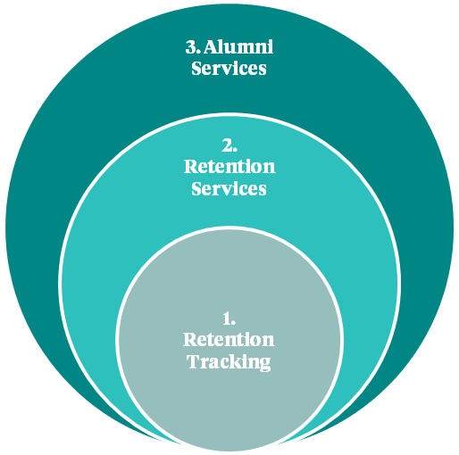

tracking employment outcomes

helping individuals retain employment

fostering connection and engagement within the community

Post-program activities can include:

* **Retention Tracking:** Tracking alumni employment outcomesis often required for reporting to funders and building a case for support. It can also provide critical information to assess program efficacy (i.e., are graduates earning living wages?) and inform alumni retention services (i.e., why are alumni leaving jobs and how could we proactively support?). Common metrics include employment retention rates at 3, 6, 12 months, starting wage, wage progression, and % of graduates in continued education pathways.
* **Retention Services:** These are services that help individuals retain employment, like ongoing case management and coaching, or upskilling opportunities. Intentional transitional support can improve alumni outcomes and increase organizational impact by proactively addressing challenges and supporting continued growth.
* **Alumni Services:** This is the broadest category and includes everything above, as well as fostering connection and engagement within the alumni, staff, and partner community.Successfulalumniengagement through activities like events or advisory councils not only improves your retention data and services, but it builds a strong alumni network of guest speakers, mentors, and employer contacts to support future learners and graduates.

|  |  |
| --- | --- |
| **Reflection** | |
| **Retention Tracking:** What key retention and post-program metrics do we track? |  |
| **Retention Services:** How do we support alumni to retain employment? |  |
| **Alumni Services:** How do we foster connection and engagement within our alumni community? |  |

# Case Management & Coaching

Continued case management or coaching is a critical service for many alumni transitioning into new jobs and overcoming existing or emerging challenges.

|  |  |
| --- | --- |
| **Reflection** | |
| **Case Management:** How do we provide case management and coaching after our program? How frequently are our touchpoints? Who is responsible for this and is there adequate capacity? |  |
| **Rapid Reemployment:** How do we help alumni find new and better jobs and minimize employment gaps? |  |

# Incentives & Wage Supplements

Financial incentives have proven to be an effective approach to increase follow-up response rates and employment retention among alumni.

|  |  |
| --- | --- |
| **Reflection** | |
| **Incentives:** Do we provide financial incentives for employment retention? How much? |  |

# Continued Learning & Training

Low pay is one of the leading factors for turnover. Continued skills development is necessary to unlock economic mobility.

|  |  |
| --- | --- |
| **Reflection** | |
| **Continued Learning & Training:** Do we provide alumni with opportunities for continued professional development or advanced training? How? |  |

|  |
| --- |
| Case Study: Alumni Transitional Employment Program at Root Root (Salem, MA) helps young adults create pathways to independence through foodservice training and employment. Their 14-week program creates hands-on training opportunities through their community meals and event catering social enterprises and youth develop personal finance and workforce readiness skills.  Like many programs, Root found many graduates needed additional support to transition from Root’s training environment into external work environments. To intentionally ramp-up alumni readiness for outside production and professional settings, Root created a three-to-six month transitional employment program.  Building on their initial training, alumni learn more advanced skills through hip-to-hip training with staff across all businesses (catering, community meals, school lunches) and gradually work more independently.  They also receive monthly check-ins on goals and performance reviews. There’s an optional off-ramp after month three for those who aren’t a fit for the second phase (for example, not demonstrating growth or having goals that are beyond what they can work on at Root).  During the last three months, participants specialize in a specific area based on their individual development plan, receive more in-depth professional development on financial literacy and job search and interviewing.  In the final month, alumni complete an externship at an employer they’ve selected, and they finish with a capstone project where they plan and execute a catering event or community meal. |

# Events & Community

Fostering community among alumni builds their confidence and sense of belonging. Maintaining and deepening your relationships with alumni in this way will also improve your ability to gather post-program data and provide employment retention support. And it creates a strong alumni network of guest speakers, mentors, and employer contacts to support future learners and graduates.

|  |  |
| --- | --- |
| **Reflection** | |
| **Events & Community:** How do we build community with our alumni? |  |

# Alumni Advisory Councils

Alumni advisory councils are a great way to center participant voice and lived experience in strategic planning, to facilitate alumni contributions to participant recruitment and alumni engagement, and to cultivate alumni leadership experience. It’s best to formalize the purpose and structure of your council in a written charter.

|  |  |
| --- | --- |
| **Reflection** | |
| **Alumni Advisory Council:** Do we have an alumni advisory council, or would we like to start one?   * Who is eligible and how will selection take place? * What are the expectations for council members? * How will members be compensated? |  |

|  |
| --- |
| Case Study: Aftercare and Alumni Advisory Council at Café Reconcile Café Reconcile is a 14-week workforce development program for young adults that provides on-the-job training opportunities through their renowned lunch café in New Orleans. Committed to nurturing the professional and personal success of young people after their program, they launched an intentional aftercare program with a dedicated Alumni Engagement and Employment Case Specialist.  The Specialist begins building rapport with youth during the training program by leading workshops on resume-building and other durable skills. After the program, alumni receive calls or home visits after one, three, six, nine, and twelve months. To incentivize follow-up and employment retention, alumni are invited to meet in-person to check in on their goals and share current paystubs to receive a stipend. Starting at $25, stipends ramp up as time increases and can total $400 over the twelve months after training.  For deeper engagement, Café Reconcile has an Alumni Advisory Council for graduates to provide critical insights based on their lived experience and inform future strategic planning. Alumni complete an online application and are elected by the current council for a one-year term. The 18 members include a Chair who serves on the Board of Directors. Members receive $250 per quarter for attending six in-person meetings and seven virtual meetings over twelve months, plus coordinating and hosting four events for alumni. These include an Annual Alumni Summit with speakers from local community partners and Saturday brunches which can double as outreach events for other youth who may be interested in the program.  Café Reconcile has seen a notable increase in alumni engagement and employment retention as a result of their aftercare program. |

# Employer Engagement

Employers have an important influence on and insight into the successes and challenges of the alumni who work there. Engaging with them proactively can reduce barriers to employment and prevent issues before they impact employment retention.

|  |  |
| --- | --- |
| **Reflection** | |
| **Employer Engagement:** How do we engage with employers to improve employment acquisition and retention? |  |