**B2C Sales/Marketing Funnel (Digital)**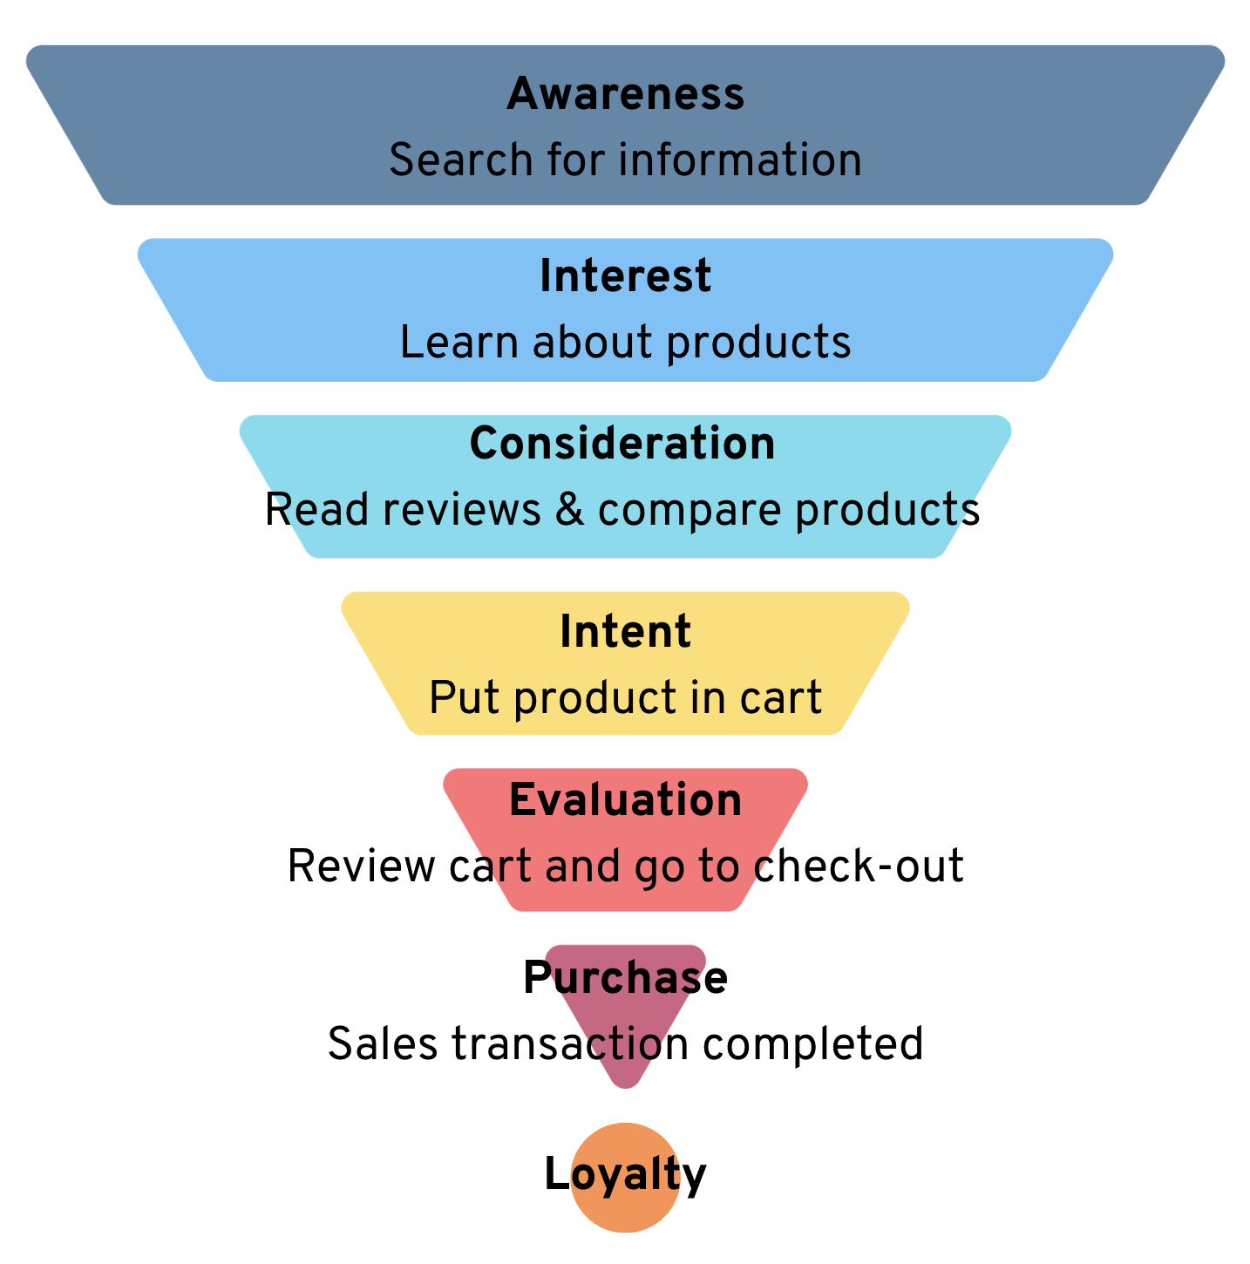

| **Awareness**  *Add your thoughts here.* |
| --- |
| **Interest**  *Add your thoughts here.* |
| **Consideration**  *Add your thoughts here.* |
| **Intent**  *Add your thoughts here.* |
| **Evaluation**  *Add your thoughts here.* |
| **Purchase**  *Add your thoughts here.* |

| **My next steps are . . .** |
| --- |

**B2B Sales/Marketing Funnel**

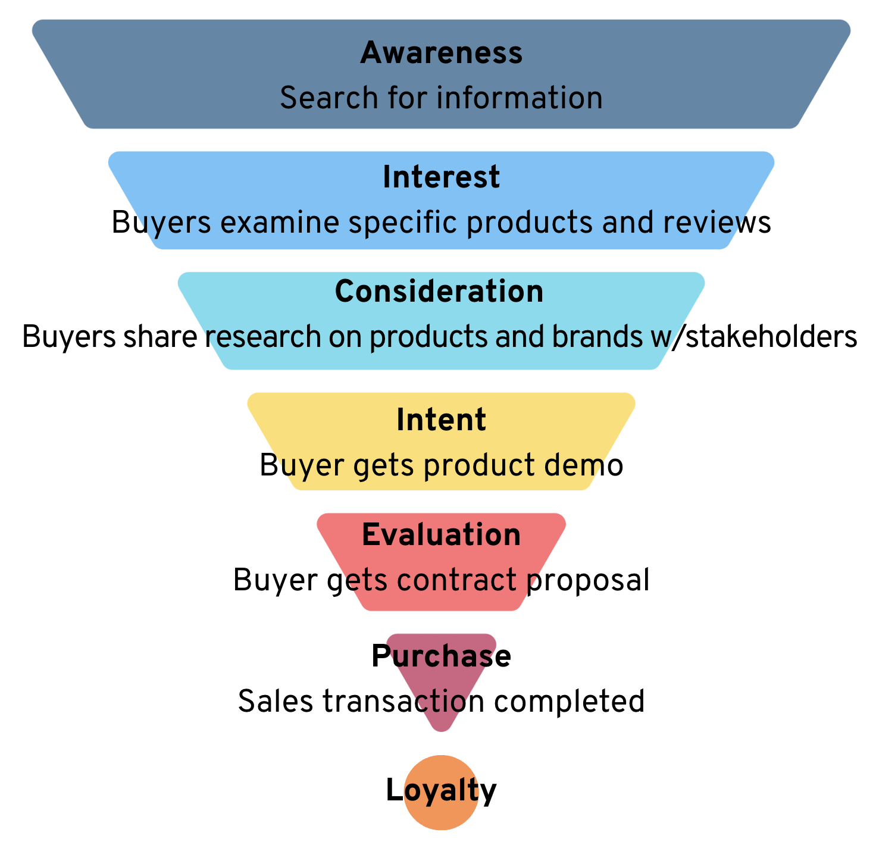

| **Awareness**  *Add your thoughts here.* |
| --- |
| **Interest**  *Add your thoughts here.* |
| **Consideration**  *Add your thoughts here.* |
| **Intent**  *Add your thoughts here.* |
| **Evaluation**  *Add your thoughts here.* |
| **Purchase**  *Add your thoughts here.* |

| **My next steps are . . .** |
| --- |

**While there are many marketing actions you can take, improving sales funnel activities comes through the 5Ps**

