**B2B Funnel B2C Funnel**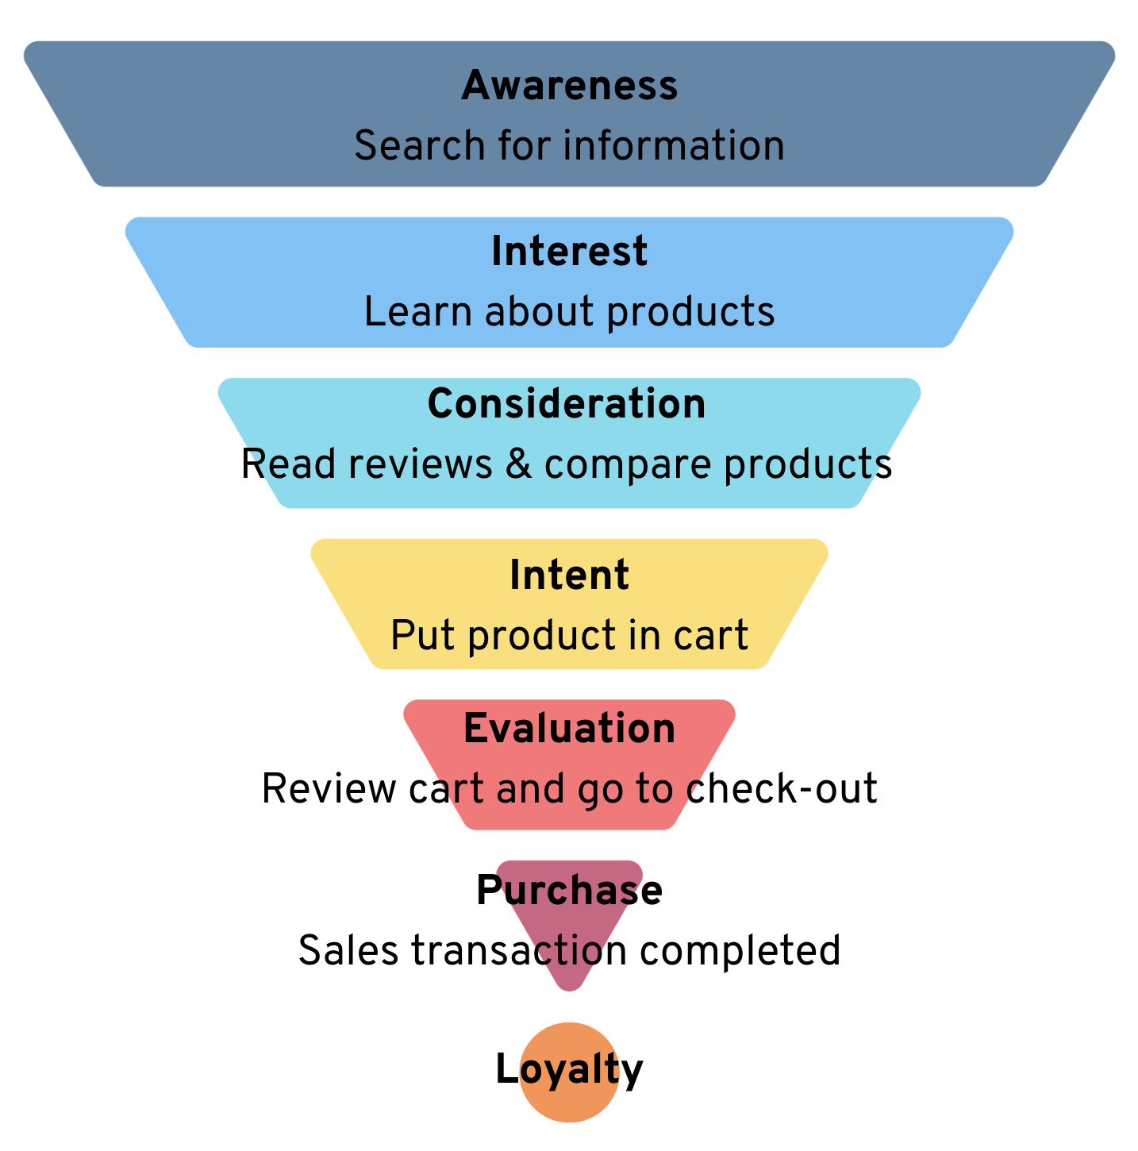

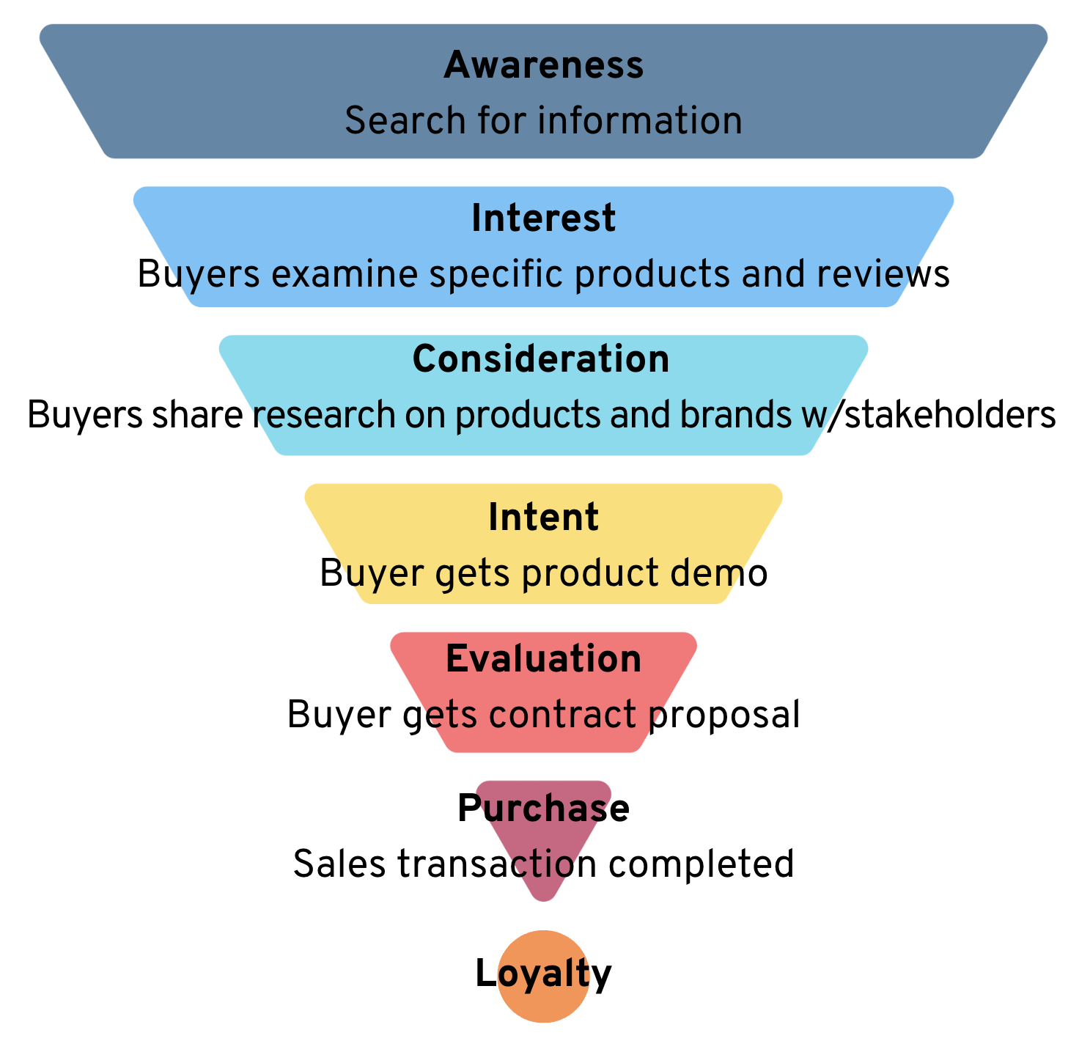

**5Ps**

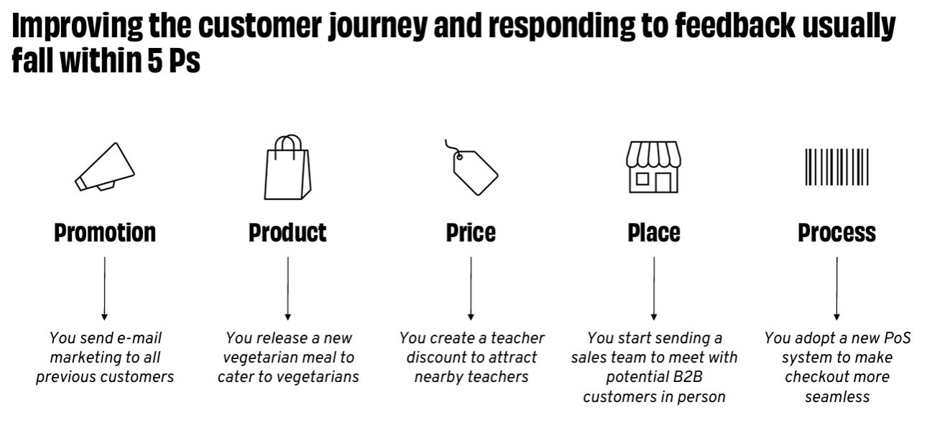

**Sales Channels Worksheet**

| ***Business*** | **B2C** | **B2C** | **B2C & B2B** | **B2C & B2B** | **B2B** | **B2B** | **B2B** |
| --- | --- | --- | --- | --- | --- | --- | --- |
| ***Channels*** | **Online** | **Special Events** | **Referrals** | **In Person Sales** | **Distributors** | **Bulk Sales** | **RFI / RFP Responses** |
| ***Additional Description*** | *- Web Store - Social Media - Email Marketing - Mobile Apps - Marketplaces* | *- Farmer’s Market - Pop Ups* | *- Current Customer Referral Program* | *- Retail Store - Sales Rep* | *- 3rd Party Retailers*  *- Resellers*  *- White Labeling* | *Wholesalers* | *- Government Contracts - Institution Contracts* |
| **Do you use it?** |  |  |  |  |  |  |  |
| **If you use it, how well does it work?** |  |  |  |  |  |  |  |
| **Are you considering using it?** |  |  |  |  |  |  |  |
| **What questions do you have about this sales channel?** |  |  |  |  |  |  |  |