

© 2025 The Management Center.

Planning Projects

The Practice Workbook
Roberts Enterprise Development Fund (REDF)
***To get your own editable copy of this workbook, click here.***

🎯 Today’s Goals
This training equips project managers with tools and strategies for transforming project visions into actionable plans while fostering equity and inclusion. Through practice with both a case study and your own project, you’ll learn to break down complex work, assign clear roles using MOCHA, anticipate and address challenges along the way.
By the end of our time together, we hope you:
- Understand how to transform project visions into actionable plans by ‘conspiring and aligning’ with project contributors and stakeholders.
- Feel comfortable applying the following project management tools and frameworks: MOCHA for role clarity and workstream planning.
- Make project decisions that advance equity, maintain team sustainability, and achieve intended results.

💬 Breakout 1: Planning Superpowers

Instructions  ⏰ 5 mins  💬 Group Size: 4 |  | First: Individual Reflection  Think about a time when your planning skills made a real difference:  - What specific approach did you use?  - How did it help the project succeed?  - What impact did it have on your team?  Then: Group Discussion  Share your Planning Superpower 🦸  - A specific example of when you used it  - How it contributed to project success

My notes:

✏️ Practice Activities 1-4: Project Planning Template

We'll use our time together as an actual planning session for your real work.  Download a copy of the Project Planning Template - this will be your working document.  Then, pick a project you want to focus on. It should be something that: Has a clear end goal, clear beginning and end, and involves working with various people (both in and outside your team). |  |  |  |  |  |  |  |  |  |  |  |  |  |  |  |  |  |  |  |  | Template (Google Sheets)
 |  |  |  |  |  |  |  |  |  |  |  |  |  |  |  |  |  |  |  |  | Template (Excel)

📄 Case Study: Know Your Rights Campaign


CARE: A statewide non-profit whose mission is to strengthen workforce development opportunities for youth
The Context
The state recently launched new workforce development initiatives focused on apprenticeships and sector-based training programs for young people. CARE’s network of educators and caregivers has asked them to prioritize:

- Coordinating access to career pathways and training programs for youth.
- Sharing information about how new policies and funding impact workforce development opportunities across the state.
CARE is now focused on both priorities.

The Project
In order to share the requested information, CARE will host a series of Know Your Rights sessions for educators and caregivers. The Program Team is responsible for:

- Developing the agenda and content for these 1-hour informational sessions.
- Delivering the sessions virtually and in-person across the state.
- Ensuring educators and caregivers understand the rights, resources, and pathways available to help youth connect with apprenticeships, training, and career opportunities.
Janelle will be project managing this initiative.

💬 Breakout 2: Project Reflection

Instructions  ⏰ 5 mins  💬 Group Size: 3 |  | Share:  - What workstream are you most concerned about? or more generally what are you concerned about?  - What could go wrong? (Consider things like stakeholders or timeline)

My notes:

📄 Resource: Project Status Meeting Agenda

Elements of a Status Meeting  Agenda Template (Google)  Agenda Template  (MS Word) |  | Progress to Goal: Workstreams and Steps  Are we on track to achieve our project goals? What progress have we made on each workstream since our last meeting?  Project Updates  What key developments, changes, or achievements should the team know about?  Roadblocks and Challenges  What's getting in our way? What support or resources do we need to move forward?  Upcoming Deadlines  What important milestones are approaching? Are we prepared to meet them?  New Commitments and Next Steps  What actions are we committing to before our next meeting? Who's responsible for what?

✏️ Practice Activity 5: Final Reflection
Imagine your project is complete and was a huge success. Looking back, write a brief celebration of your project addressing:
Results: What impact did you achieve?
Equity: How did you ensure diverse voices were heard, particularly those most impacted by the project? How did you provide stakeholders with the resources and support they needed to contribute meaningfully?
Sustainability: How did your timeline and workload planning prevent burnout? What choices did you make to give people the space and time they needed to do quality work?

📚 TMC After Training

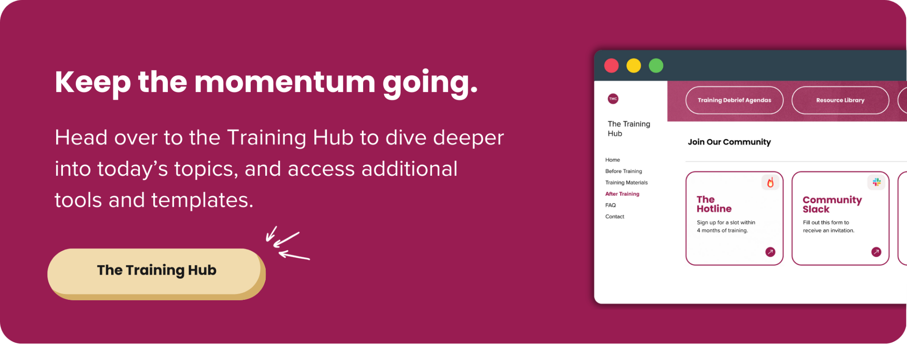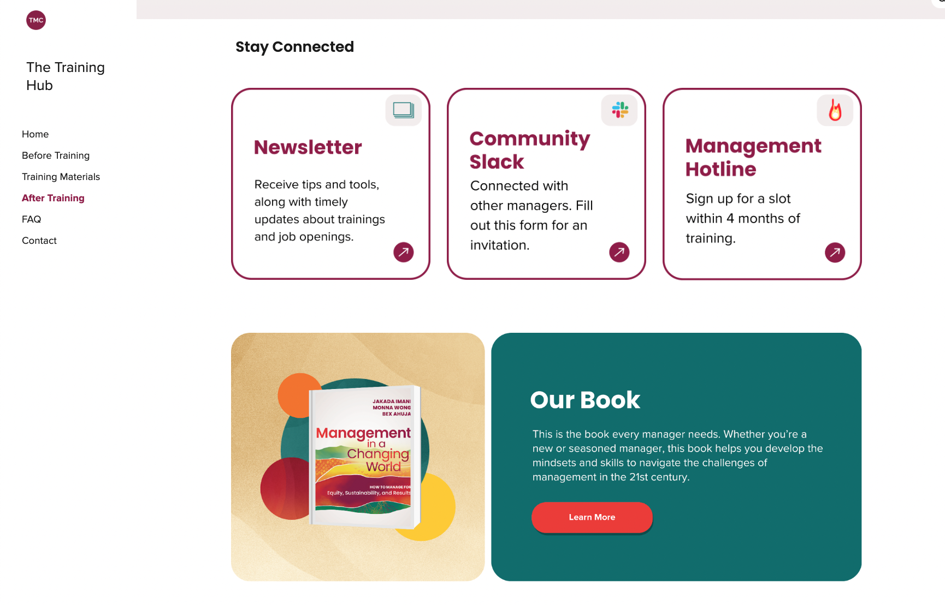

Tools and concepts we covered today

✅ | The 5Ws
✅ | Workstreams
✅ | MOCHA
✅ | Cascading MOCHA
✅ | Steps
✅ | Dependencies
✅ | Risks
✅ | Mitigations (trade-offs)

