

© 2025 The Management Center.

Managing to Change the World

The Practice Workbook
Roberts Enterprise Development Fund (REDF)
***To get your own editable copy of this workbook, click here.***

Today’s Goals
This course is designed to inspire and equip managers at all levels – including new managers, seasoned managers, and managers of managers – to lead with a sense of duty and a comprehensive understanding of effective management principles.
By the end of our time together, we hope:
- You adopt a belief that you have a responsibility to manage effectively – management that is equitable, sustainable, and results-driven.
- You are able to identify at least one key management approach, concept, or tool that could improve or refine your day-to-day management practices.
- You begin to develop an action plan for your continued growth, outlining next steps for applying the learned concepts and tools, and identifying any areas for further skill-building.

💬 Breakout 1: Giving Feedback to Habib

 |  | Reflection  Habib is now preparing for their next project. As Habib’s manager, what would you do to ensure they are successful?  - Have an additional feedback conversation; and ask how you can better support them.  - Create space to reflect on the last project and set goals for the next one.  - Play a more active role in the planning and execution of the work.  - Reflect on Habib’s strengths and weaknesses; re-delegate the more challenging aspects of the project to other team members with a stronger skillset.
Imagine this: Habib, one of your team members, just wrapped up a big project that, frankly, missed the mark. This wasn't just any task – it was a major part of their goals for the year. In the end, you and the rest of the team had to unexpectedly get involved to meet the deadline.

Afterwards, you met Habib for a feedback chat. The conversation was okay, but you left feeling that they didn't really get it. You know, that sinking feeling when you're not sure if your message actually landed.

Breakout Instructions | ✏️ My Notes
- First: Share what you would do as Habib’s manager, and why.

- Then: What beliefs - or experiences - about management informed your chosen path?

- After: Together as a group, we will discuss the scenario and possible approaches.

✏️ Practice Activity 1: My Management Values
Our values drive our management practices. These are things like trust, accountability, authenticity, equity, sustainability, results-focus, or empathy – and more.  Below, reflect on your management values and how you came to hold them.  Next, we’ll discuss your reflections as a group. | 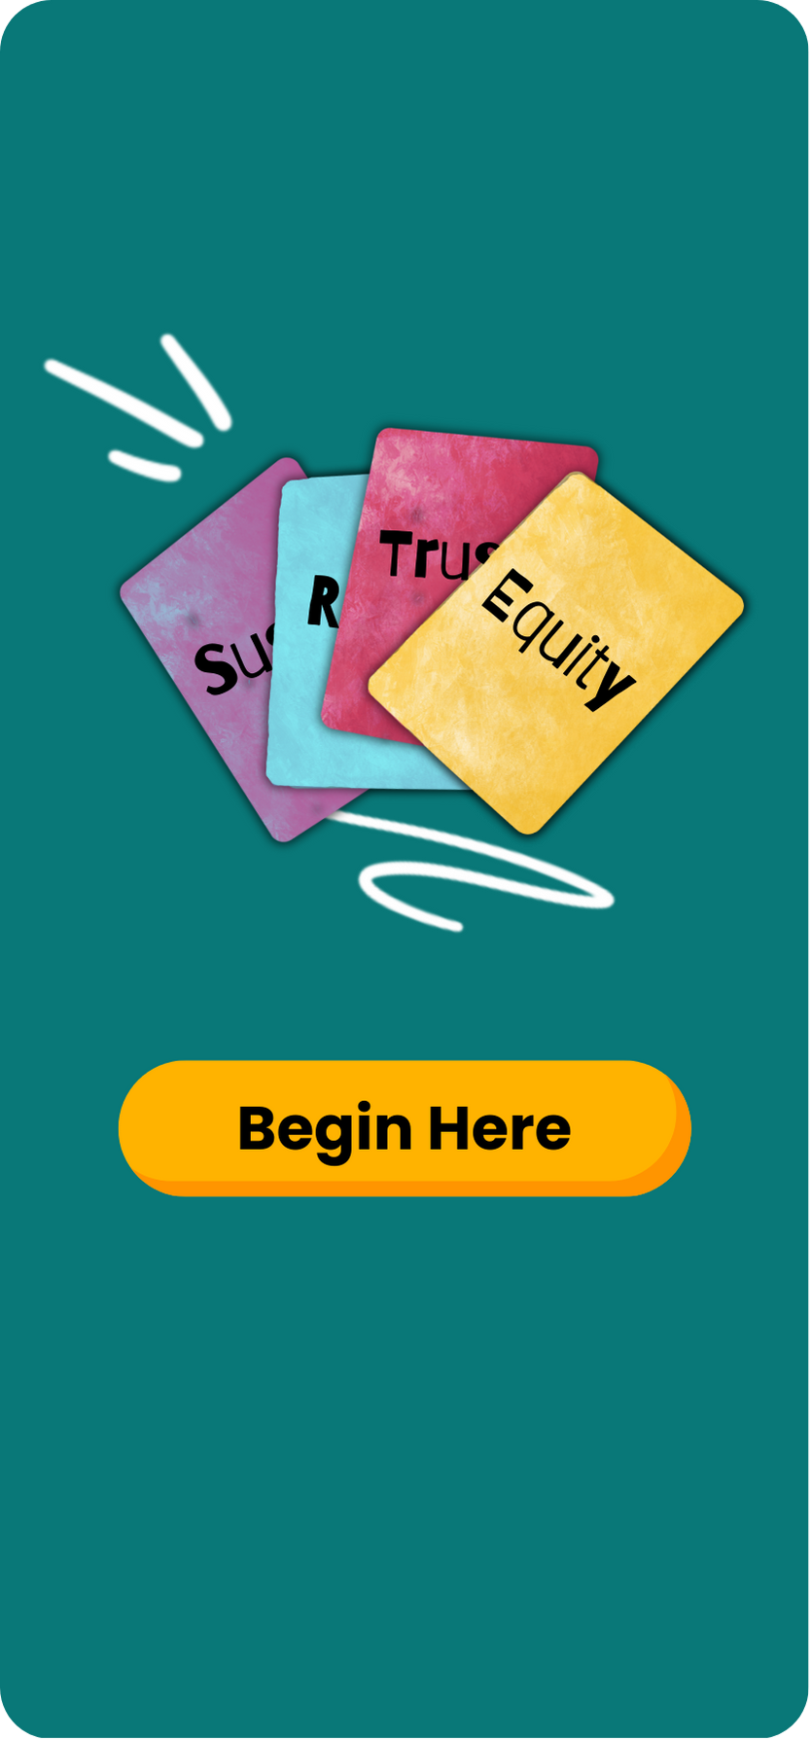

Think about the values that inform your management (see our short list of common values above if you need inspiration). Name at least one value, and describe an example of how it shows up in your management.

How did you learn to be a manager, and what values were instilled through that process? Are these values you want to hold on to or let go of?

💬 Breakout 2: Our Experiences with Conspire & Align

Conspire and Align is about coming together with our team for a collective purpose and getting on the same page about realizing that purpose. When we conspire and align, everyone understands where we’re going and our role in getting there. When a team works well together, it’s not limited by the brilliance of one person – its members’ combined powers are greater than the sum of their parts. This is a contrast to a more traditional, command-and-control style of management. | 

Breakout Instructions | ✏️ My Notes
Discuss: Share a time that you practiced or experienced ‘conspire and align’ (even if you didn’t call it that at the time).

✏️ Practice Activity 2: Check-In Meetings
Check-In Essentials |  | 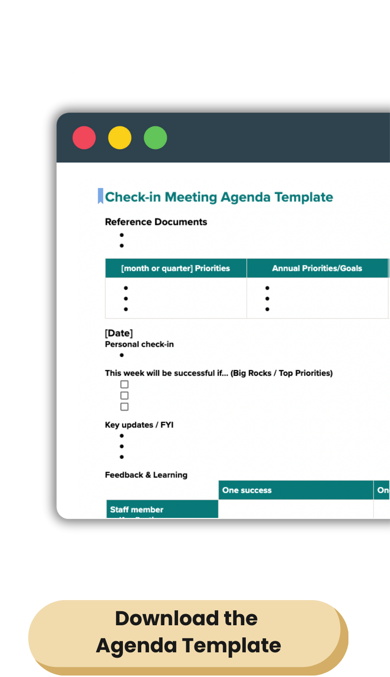
The staff member drives the meeting: They should draft a check-in agenda and share it with you ahead of the meeting.
Check-In: Start with a personal connection; updates from life outside of work.
Align & Troubleshoot: Check on progress towards goals, prioritize coming work, and address challenges or hurdles that need resolving to move the work forward.
Share feedback: Make space to give feedback to the staff member and for them to give you feedback.
Next steps: Capture clear next steps.

Reflection and Whole-Group Discussion

Think about your experience with check-in meetings. How valuable are your check-ins right now? How have these meetings helped strengthen relationships with your team?

What might you try to do differently going forward?

Next Steps
One change I’d like to make to my check-ins: | My first step is to…

📚 Resource: The Three Dimensions of Effective Management
The Management Center believes that effective management can deliver results that promote justice and build power. Our definition of effective management includes three co-equal parts:
- Equity: Managers work to create an environment where staff (particularly those most negatively impacted by white supremacy and other systems of oppression) experience belonging and thrive in their work. | 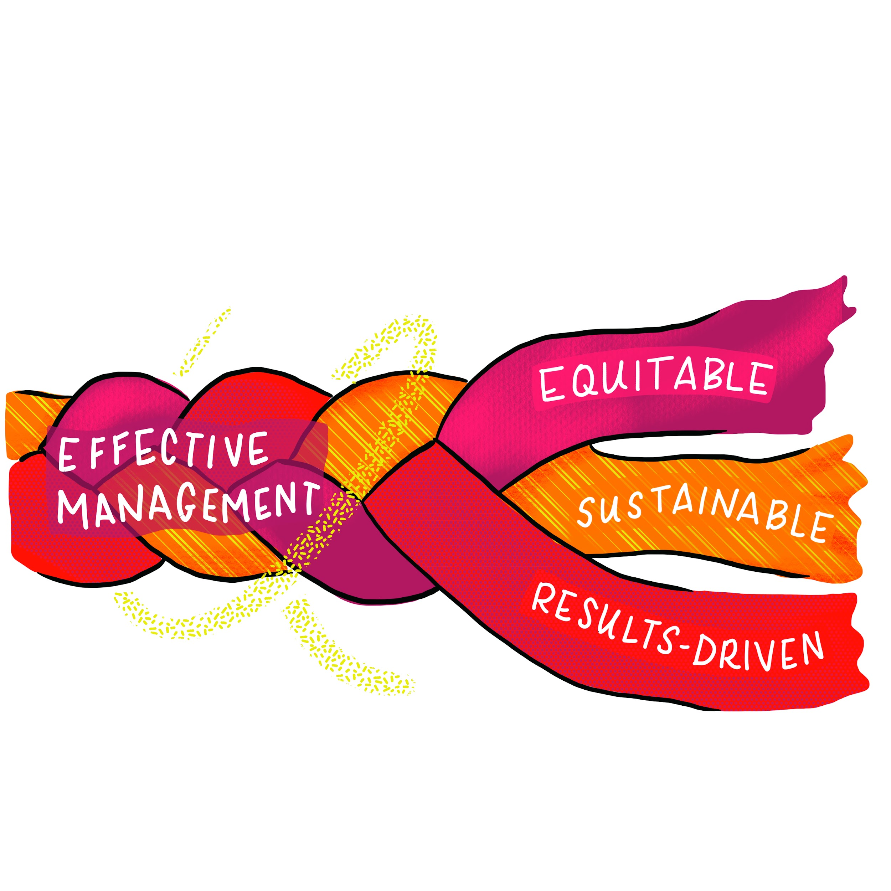
- Sustainability: Managers work with the long view in mind by investing deeply in people, relationships, and systems to produce results and a healthy organizational culture that endure over time.
- Results-driven: Managers make delivering excellent outcomes a guiding priority. By defining clear roles and goals, managers create a culture of shared accountability and commitment to advance the organization's mission.

✏️ Practice Activity 3: Bias Check
Do a Bias Check  As managers, our responsibility is to recognize the ways our unconscious biases may lead us to favor certain people on our teams. We learned about ‘filters’ we sometimes apply in favor of people like us, people we naturally click with, or people with dominant culture or mainstream identities and experiences. | 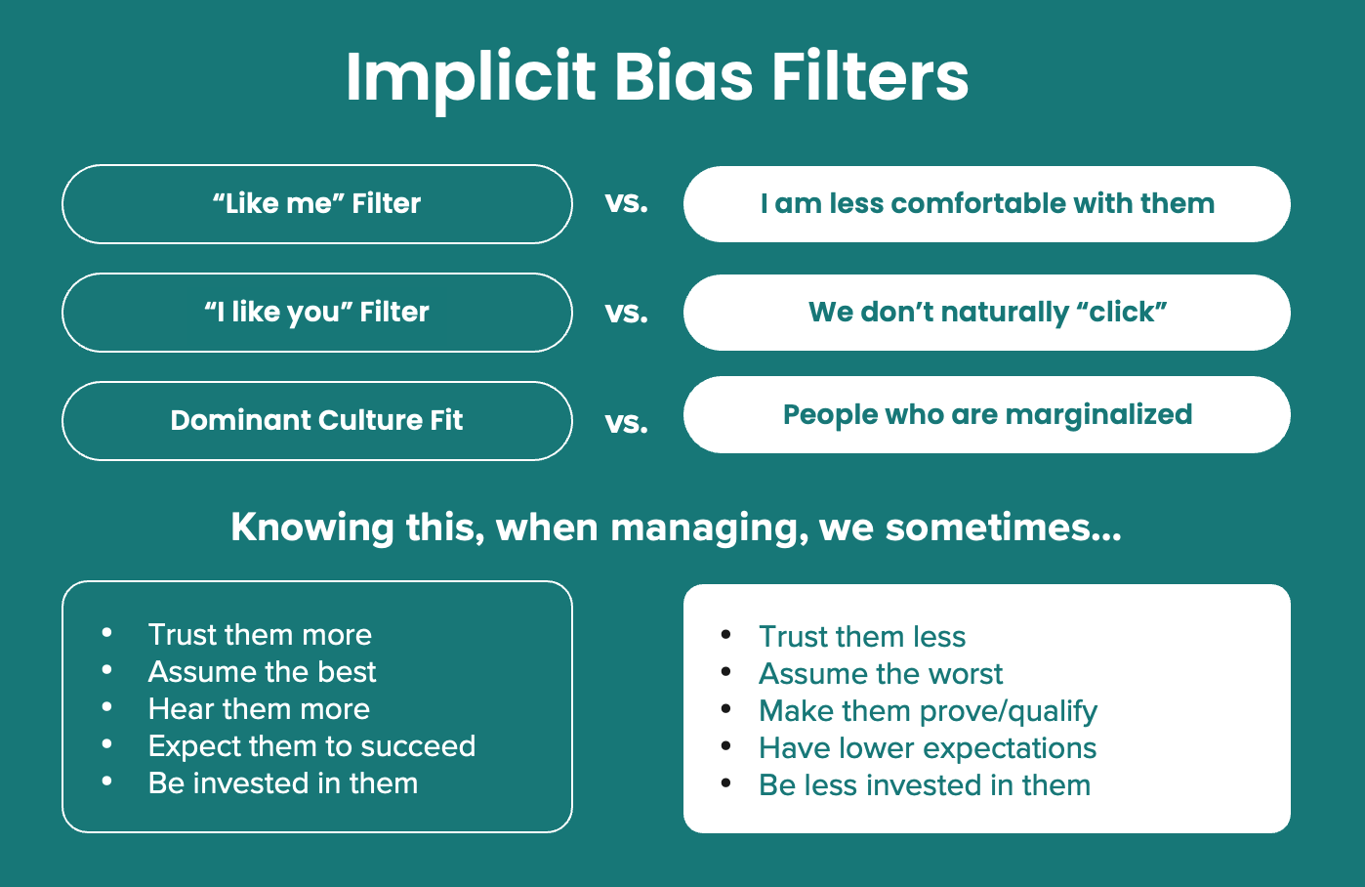

List each of the people you manage in the table below and consider the extent to which you use these effective management practices with them. o

Management Practices | People I manage
 | Name
Check-in regularly (and effectively)
Give them frequent and specific feedback | X
Assign rigorous work and support them to succeed
Seek their input and perspective | X
Fill in: | X

What patterns (if any) do you notice, particularly with regard to race or other identities like gender, age, educational background, and positional power? Where could your bias be showing up? What impact might these choices have on equity, inclusion, and belonging?

✏️ Practice Activity 4: Delegating Effectively

Part 1 | Choosing a Project to Delegate: What’s a task or project you need to delegate in the coming weeks?

Part 2 | Outlining a Delegation Plan. How would you answer the 5Ws for the task or project you’re delegating?

 |  | What outcomes are you looking for? What would success look like? How will you make the implicit explicit?
 |  | When does it need to be completed? What are benchmarks along the way?
 |  | Where else can they go for resources, examples, or advice?
 |  | Why is this task important? Why [name of staff person]? Why this? Why now?
 |  | Who should be involved? For this exercise, only focus on the Manager and Owner. For more on MOCHA → check out this guide.  Owner  Manager
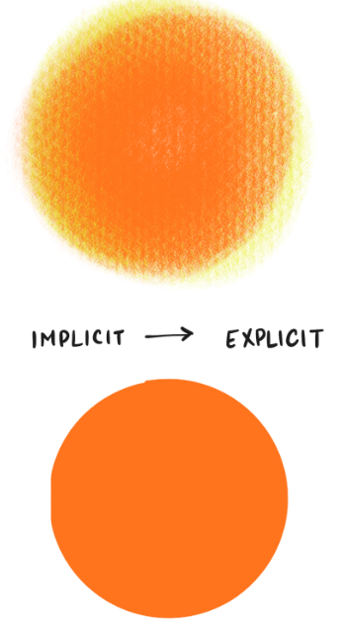 |  | Making the Implicit, Explicit: What are your assumptions? Is there anything you're worried about that you haven’t shared explicitly?
Part 3 | PTR & Seeking Perspective: Get clear about your preferences, traditions, and requirements. Figure out where to seek perspective.

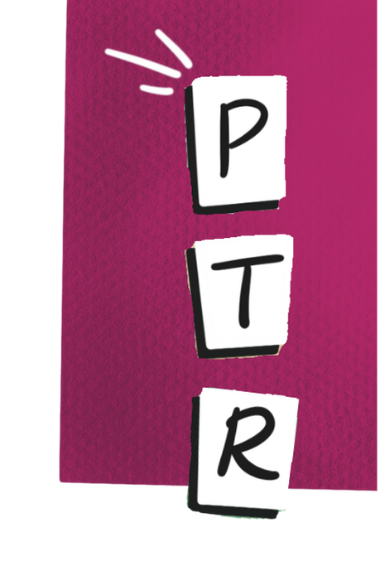 | PTR Check: What are the requirements of the task/project and why?
 | How are your preferences and traditions showing up? What preferences might you let go of, or how can you be explicit about a preference or tradition you feel strongly about?
Seeking Perspective: How might you gather information from the people who might be most impacted? Select which of the following questions you would ask – or write your own:

- Here’s what I'm thinking. What do you think?
- Have you done something like this before? What worked? What didn’t?
- What are you excited about? Anything you’re nervous about?
- Is there anything else you want to discuss?
- Draft your own question:

Now, go back and revise the 5Ws of your delegation plan as needed to reflect your PTR check or plans to seek perspective.


Download
Sample completed Delegation Worksheet

💬 Breakout 3: Delegation Role-Play

Part 1
- Person A: Delegates their project to Person B.
- Person A: Clearly communicates expectations using your 5W outline.
- Person B: Listens attentively and asks clarifying questions.
Part 2
- Debrief: What went well in the delegation? What could be improved?
Part 3
- Switch roles: Person B now delegates their project to Person A.
- Follow the same process as in Part 1.
Part 4
- Debrief: Discuss the same points as Part 2.

✏️ Practice Activity 5: Taking Slices

 |  | Slices are small samples of the work in progress. As much as you can, try to build slices into your plan from the beginning, so that you and your team members can expect them.  Plan the slices for the project you are delegating. What specific products or activities (e.g., outlines, data, drafts, etc.) will you want to review or see in action to track progress?

Don’t forget to debrief a project you’ve delegated, too! Review the debrief template on TMC’s website.

✏️ Practice Activity 7: Creating Your Action Plan

Today we've filled our management toolkit with a variety of foundational tools.

Now it's time to bring it all together by reflecting on your next steps as a manager.

Here’s a list of approaches and tools we covered today:

- Conspire and Align | - Delegation: the 5Ws
- Check-Ins | - PTR (preferences, traditions, requirements)
- 3 Dimensions of Effective Management | - Making the Implicit Explicit
- Margins & Mainstreams | - Seeking Perspective
- Bias Filters | - Taking Slices
- Choice Points | - Giving Feedback

Looking at the set of approaches and tools we covered today, which topics are most important for you to focus on in the coming weeks? List them.

How might you continue to develop your management practice? What’s the one thing you commit to doing next?

Envisioning Your Success

Imagine applying your prioritized management approaches and tools over the next few months to address key challenges at work.
Consider: What support or resources will you need? How might you source those? How will it feel to overcome current management challenges? What tangible changes will you see?

📚 TMC After Training

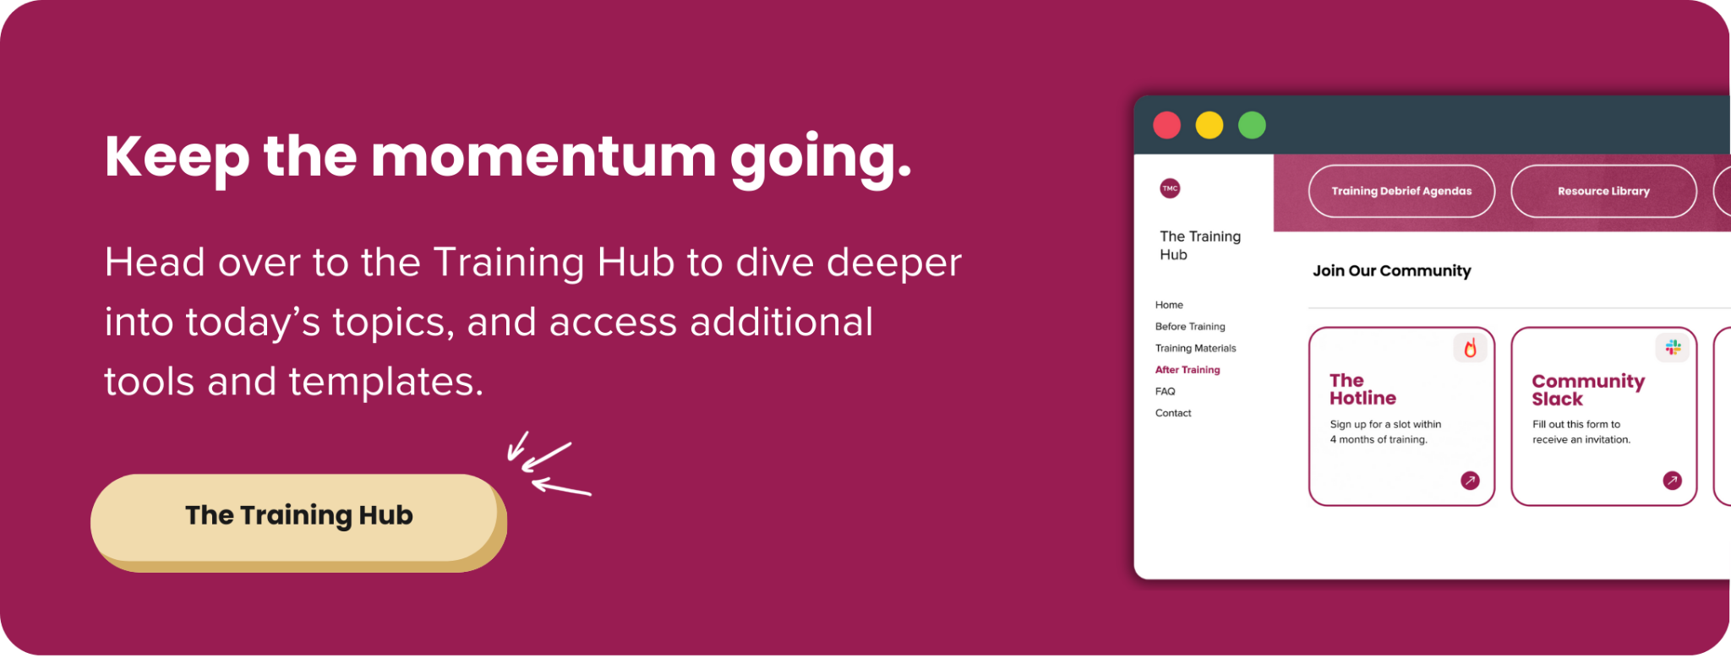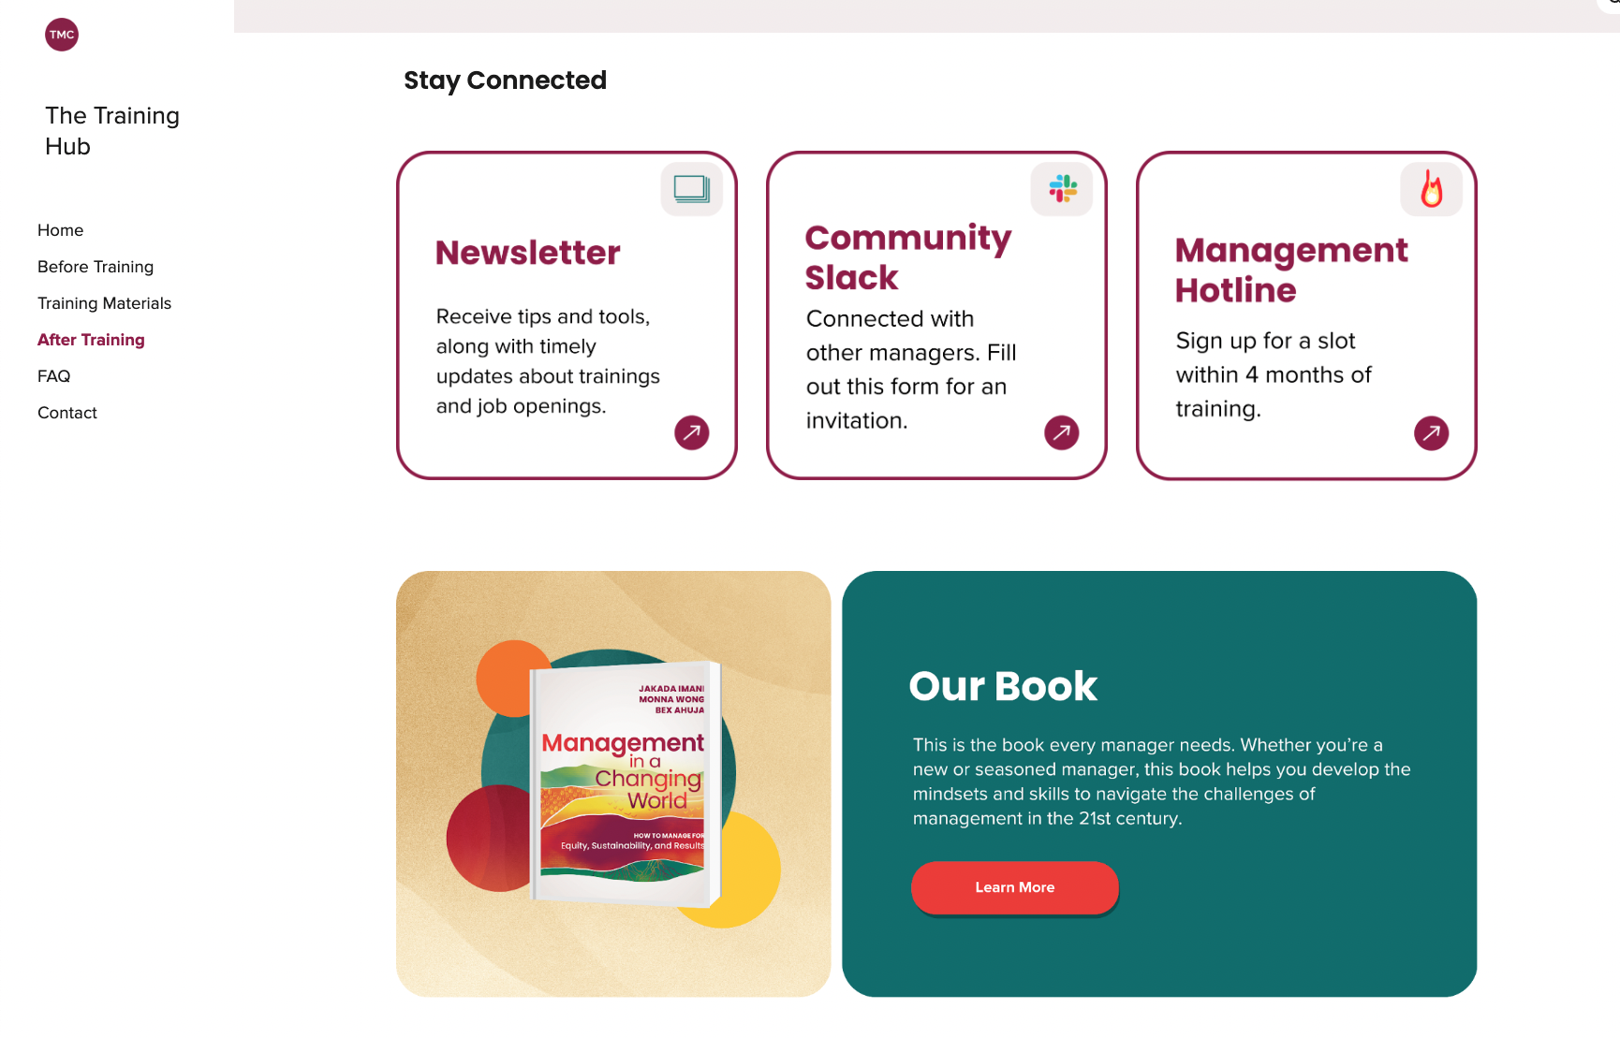

Join us for more training!
- Giving Feedback
- Driving Impact with SMARTIE Goals
- Making Better Decisions
- Hiring Your Team
- Building a Healthy Team Culture

