© 2025 The Management Center

Managing Up and Sideways

The Practice Workbook
Roberts Enterprise Development Fund (REDF)
***To get your own editable copy of this workbook, click here.***

🎯 Today’s Goals
This training aims to empower you with strategies for managing up and sideways. Through interactive activities and practical tools, you will learn how to engage more effectively with your managers and colleagues. Additionally, you will gain a clearer understanding of what lies within your sphere of control, enabling you to focus your efforts more strategically and build stronger, more productive relationships.
By the end of our time together, we hope:
- You believe in the value of building relationships when managing up and sideways.
- You are prepared to use at least one tool to better engage with a manager or peer.
- You are able to identify what’s in and out of your sphere of control.

✏️ Practice Activity 1: Sphere of Control

What’s in your control?  You can focus your time and energy on things you can control to make a greater impact where it matters most. Through four simple steps—naming the situation, identifying what's outside and inside your control, and taking action—you can move from feeling stuck to finding practical solutions.  Meet Michelle  Michelle is a project manager who's facing some common workplace challenges.  Click the button to read Michelle's situation and identify what falls within her sphere of control. | 
 | 

✏️ Practice Activity 2: Ladder of Assumptions Reflection

Think about the thing that you named that frustrates you – or something else if this content brought up a different memory.  Reconsider that situation, and ask yourself:  - Are there any beliefs you are holding onto? Where do they come from?  - Is there data that you may have filtered out?  - What assumptions could you set aside for now? | 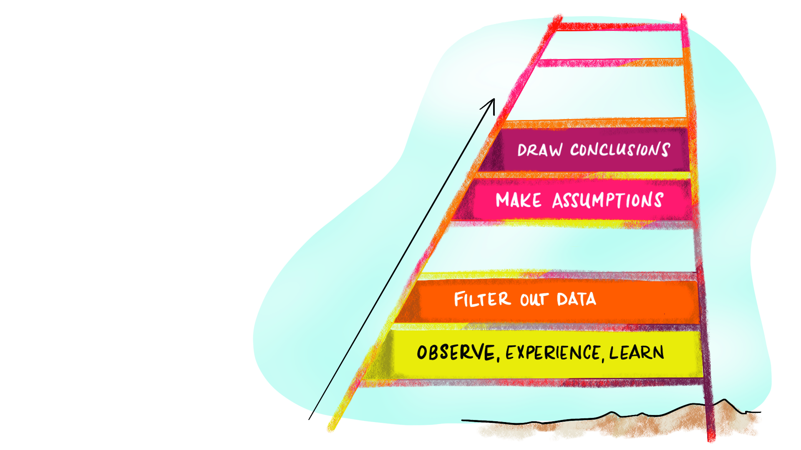

Reflections:

What is the impact on your work and collaborative relationships when you escalate up the ladder of assumptions?

💬 Breakout 1: Taking Stock
Breakout Instructions | ✏️ My Notes
💬 Group Size: 3
In your small groups, reflect on the managing up strategies we’ve covered. Share:
- Which strategy feels most challenging to implement?
- What concrete steps could you take to build confidence in using this strategy?
- What support might you need to effectively apply it?
Use the strategy overview below as a reference during your discussion.

Strategy Overview

 |  |  | Sphere of Control  Focus your energy on what you can directly influence rather than what you can't. Identify the situation, determine what's outside and inside your control, then take purposeful action.
 |  |  | Conspire and Align  Work collaboratively toward shared goals by exercising power thoughtfully. Focus on co-creating solutions and building alignment through understanding others' needs and constraints.
Ladder of Assumptions
Recognize how you might move from observation to action. Practice pausing and examining your assumptions before acting.

📚 Making Proposals: How To Say It

Sometimes, the hurdle to making a strong proposal isn’t the idea for how to address the problem, it’s getting stuck on how to say it. Here are some example proposals you can draw from.

Part 1: Offer a suggestion
Timeline
- Instead of trying to do both in-person sessions simultaneously, I suggest we set them a week apart to account for the recruitment effort we planned.
- Senior leaders have identified this as the highest priority for our team right now, so I am suggesting that we postpone the database development until next quarter.
- So that we can move the project forward while you’re out, I’d like to find some extra check-in time to get the details I will need from you.

Priorities
- Given our workloads, I'd like to propose that we give about 80% effort toward the development of this team meeting agenda, meaning that we align on outcomes and discussion questions but don't create a complex team-building exercise.
- Based on the organizational vision you shared, I think my team’s priorities should be A, B, and C.

Roles
- I can take on creating talking points for the presentation but don't have the capacity to build slides. I'd like to propose that we hire Amina as a contractor to get the slides done on time.
- To get everything done on time, I’m going to need some additional support. I think that Jose would be great at handling these things and that we should check with his manager to see if he has capacity to help out.

Roadblocks
- We haven’t been able to confirm the speaker for the event. I talked to the team, and we recommend that we confirm XYZ as a backup speaker, because we have a strong relationship with their office.
- Our website vendor won’t be able to make the updates before we launch our new program. I’d propose that we actually pull down the information that will be outdated and replace it with a simple ‘coming soon’ page so that we don’t mislead any visitors around the launch time.

Part 2: Ask to learn & confirm
- Do you have any concerns with that approach?
- Does that align with your vision?
- Is there anything you think I am missing?
- Could that work with your/ your team’s schedule?
- Is there any additional context you’d like me to consider?

✏️ Practice Activity 3: Relationship Building - 4 Elements
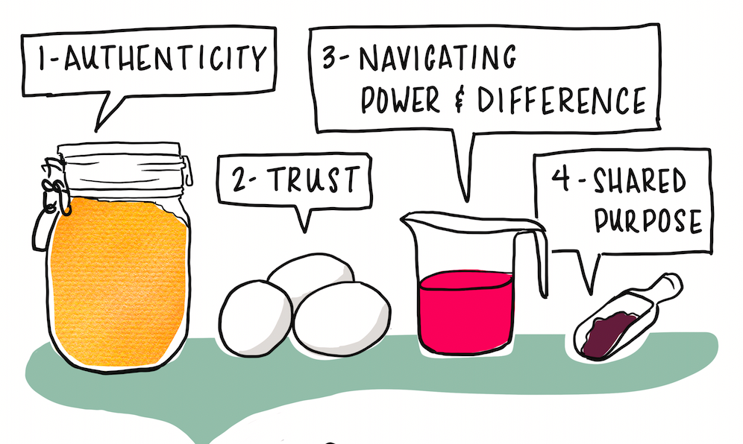
Practice and Encourage Authenticity  - Using correct pronouns  - Checking in about preferences and access needs  - Setting and respecting boundaries  - See, appreciate, and value teammates |  | Cultivate Trust  - Do what you say you’ll do  - Seek perspective when making decisions  - When you miss the mark, own up to it and do better next time  - Give credit to others  - Give and seek honest feedback
Navigate Power and Difference  - Name identities, power, and potential biases  - Use your power to remove barriers and support others  - Acknowledge and celebrate differences  - Make space for different perspectives |  | Align on Shared Purpose  - Share the context and strategy at the start of a project  - Be clear about roles and expectations  - Debrief projects when they are complete  - Celebrate progress
Review the four elements of relationship building. Then, think about a relationship you have with someone you work with frequently. Which of these elements could help you strengthen the relationship? How?

💬 Breakout 2: From Passive to Strong Asks
Breakout Instructions | ✏️ My Notes
💬 Group Size: 4-5
First: Choose one Passive Ask from your Padlet board to work on together.
Then: Discuss how to transform it into a Strong Ask.
After: Post your suggested Strong Ask on the Padlet board.
Remember, a Strong Ask should be:
- Clear about the need and why it matters
- Considerate of the receiver's other commitments
- Direct about what is needed and when

✏️ Practice Activity 4: Giving Sideways Feedback

Part 1: Reflection

Think of a project or work where you should (or should have) given feedback to a collaborator.

Who is the person? What is the thing they did, said, or didn’t do that you want to provide feedback on?

What was the impact of that thing on you or others?

Pause here to discuss with the full group

Part 2: Plan

Make a plan to either deliver the feedback you wrote about (if it is timely) or for how you want to approach the next time you have feedback for a peer (if your example is in the past and no longer appropriate to address).

Consider:
- when you will speak with the person
- how you will open the conversation
- how you ideally want them to feel or experience the conversation

Tips for Giving Feedback Sideways – And How to Say It

Get consent to share, particularly for the time and method | Sample starters:  - I have some thoughts about x. Is now a good time to share them?  - I think we had a gap in our understanding of the must-haves for this report. Can I share some feedback from my perspective?  - I have some feedback about our roles on the project. Would you prefer I share it verbally or in writing?  - I know figuring out how to deal with the software issues has been challenging. Can I share some feedback?
Share observations, not judgements | For example:  - “I noticed that you did X,” not “It seems like you don’t care.”  - “The memo was done on Friday instead of Tuesday,” not “You have no respect for other people’s time.”
Share the impacts on you or the work | As in:  - When you missed the deadline, I had to scramble to pull everything together later that week.
Make a specific request if you’re asking them to change something (don’t hide the ball) | Try:  - Next time, if the timing looks tight, could you give me 2 days' notice that the deadline might not work?  - On the next project, please include me in the team meetings.

If you aren’t familiar with TMC’s CSAW model for giving feedback, consider reading our overview or attending our Giving Feedback training for managers.

📚 TMC After Training

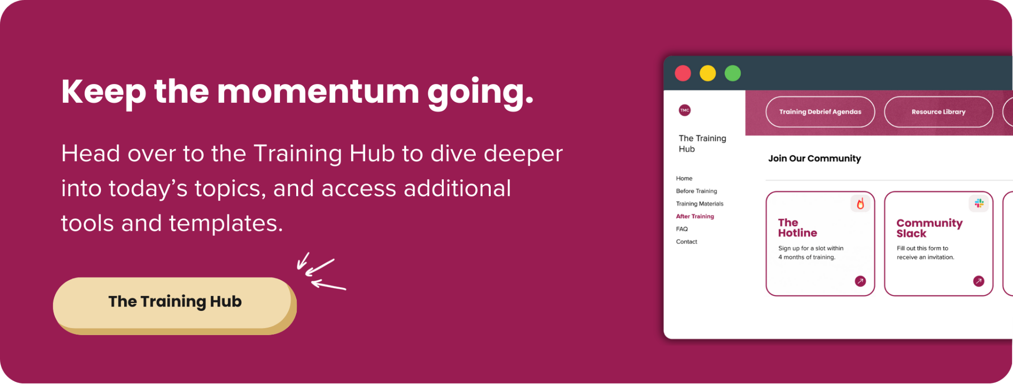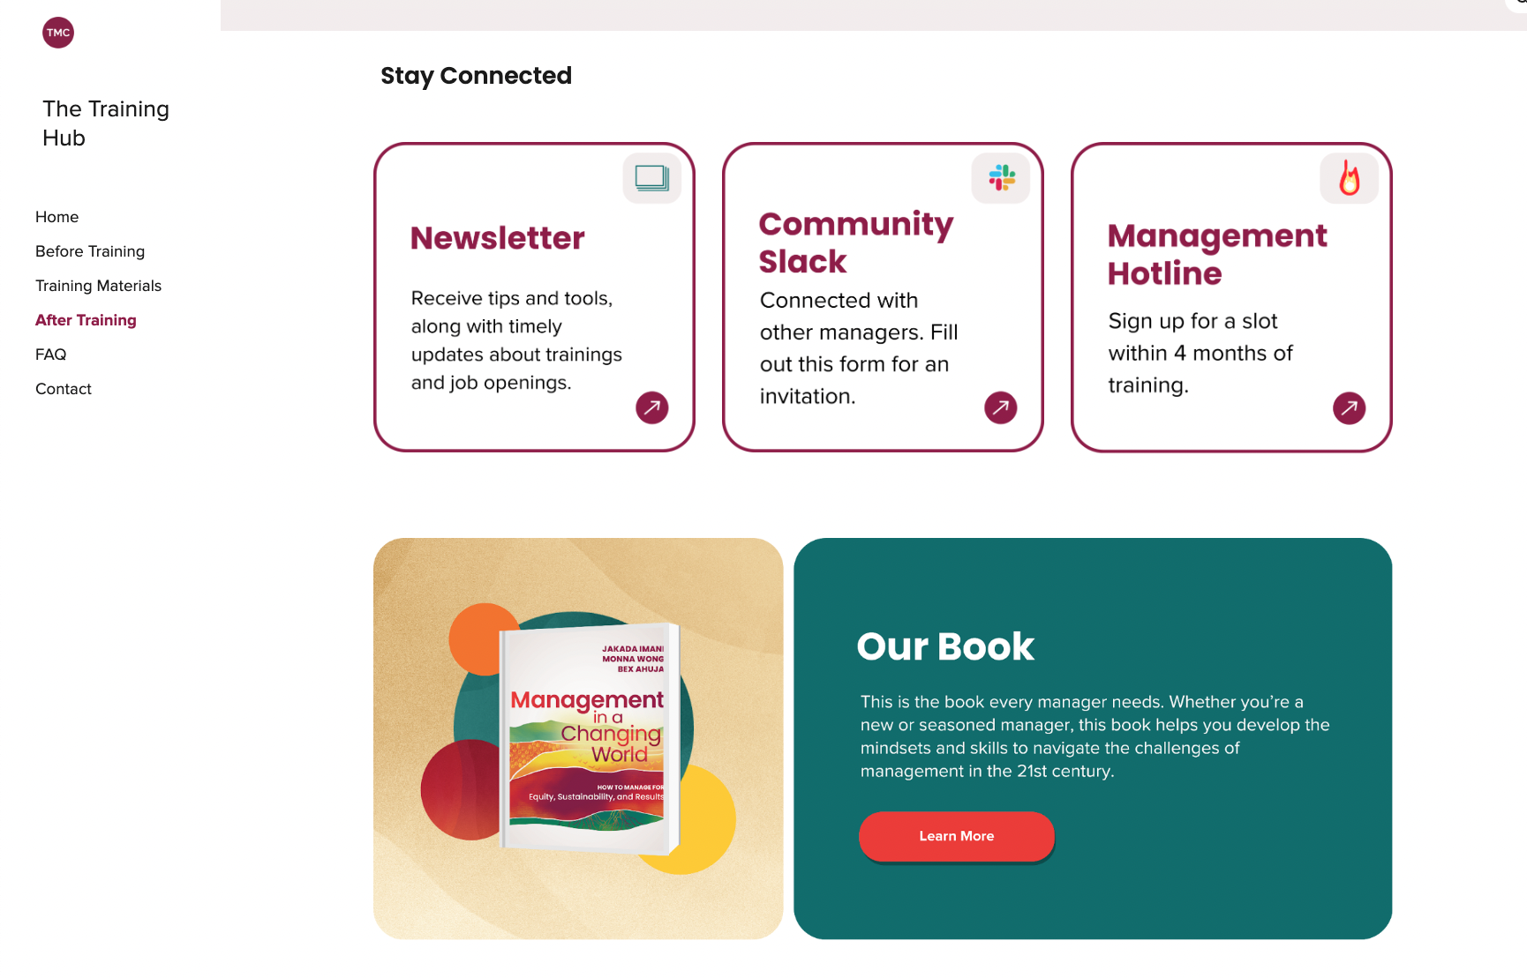

Tools and concepts we covered today

✅ | Conspire and Align
✅ | Sphere of Control
✅ | Ladder of Assumptions
✅ | Making Proposals
✅ | One-Minute Email
✅ | Strong Asks
✅ | Building Relationships
✅ | Delegation - 5Ws
✅ | Giving Sideways Feedback

