

© 2025 The Management Center

Investing in People and Performance

The Practice Workbook
Roberts Enterprise Development Fund (REDF)
***To get your own editable copy of this workbook, click here.***

🎯 Today’s Goals
Developing people is an essential skill for effective managers. It helps people grow, strengthens relationships, and yields better outcomes. In this training, you’ll learn how to develop staff strengths and address performance problems equitably. You’ll explore how to differentiate performance issues and development areas so you can support people to excel and leave with tangible action steps.
By the end of our time together, we hope:
- You believe that developing team skills and competencies is a worthwhile investment and one of your responsibilities as a manager.
- You can name at least one way to address performance problems equitably.
- You leave the training with a strategy to support the development of one of your staff members.

💬 Breakout 1: Spotting Performance Problems
Instructions  ⏰ 10 mins  💬 Group Size: 4 |  |  |  | First: Take a moment to do quick introductions (name, pronouns, org, role).  Then: Discuss these scenarios and determine if it’s most likely a performance issue, development area, or management issue.
Performance problems reflect areas of a staff member’s role where they are not meeting expectations and those expectations are a requirement for the role.
Development areas reflect skills that would help take a staff member from good to great.
Management issues are when a staff member’s success is limited due to something their manager is doing or not doing (e.g. not providing clear expectations or providing vague feedback or none at all).
Scenario 1 |  |  | You run a communications team. One of your team members has been excelling at drafting public-facing communications (remarks, speeches, and press releases). You believe they could be an excellent spokesperson for the organization – they understand the messaging strategy and use concise, powerful phrasing. However, they lack experience with public speaking.
Scenario 2 |  |  | You are a Development Director. Your grants writer is technically meticulous—they ensure every detail is perfect before submissions—but they struggle in meetings with funders. You've started finding reasons not to include them in these meetings, as they tend to make awkward comments or give overly technical, uninspiring answers to funder questions.
Scenario 3 |  |  | You run an after-school program that places recent graduates from the community in elementary schools to support students' academic and social skill development. While new staff members typically need several weeks to master classroom behavior management, one staff member continues to struggle despite receiving two months of feedback, coaching, and modeling support.

✏️ Practice Activity 1: Reflection and Strategy

Choose 1-3 people you manage and identify one thing you'd like each person to improve. For each improvement area, determine whether it's a performance problem or a development opportunity.

Just focus on listing the staff members and their improvement areas for now. You'll keep this list at the top of your mind throughout this training as we explore various tools and strategies you might apply as potential solutions.

Staff Member:
What is the issue or skill that needs to be developed?

Is it mostly a:
- Performance Problem
- Development Area
Pause here - we’ll return to talk about solutions later!
For Performance Problems: What next steps will you need to take to reflect, check-in, assess, or decide?

For Development Areas: list ways to use “I do, We do, You do” or stretch assignments to develop this skill.

My plan of action:

Staff Member:
What is the issue or skill that needs to be developed?

Is it mostly a:
- Performance Problem
- Development Area
Pause here - we’ll return to talk about solutions later!
For Performance Problems: What next steps will you need to take to reflect, check-in, assess, or decide?

For Development Areas: ways to use “I do, We do, You do” or stretch assignments to develop this skill.

My plan of action:

Staff Member:
What is the issue or skill that needs to be developed?

Is it mostly a:
- Performance Problem
- Development Area
Pause here - we’ll return to talk about solutions later!
For Performance Problems: What next steps will you need to take to reflect, check-in, assess, or decide?

For Development Areas: ways to use “I do, We do, You do” or stretch assignments to develop this skill.

My plan of action:

💬 Breakout 2: Case Study

Instructions  ⏰ 15 mins  💬 Group Size: 4-6  First: Read or listen to the full case study (below).  Then: Discuss the case using the reflection questions as a guide. |  | 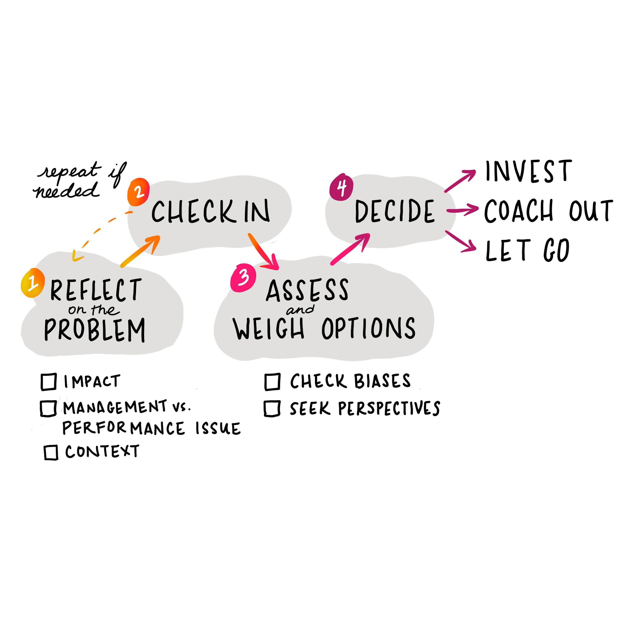
Imagine that your development manager missed their last two report deadlines. The development manager has been on staff for two years, and has generally had solid performance before these recent misses (with a few blips here and there that were quickly addressed). What do you do next?
1. Reflect
First, consider the context. The last two months have been your team’s busy season, and you were serving on an interview committee. You had to cancel several check-ins–missing some opportunities to offer support, share feedback on drafts, and workshop problems together.
At the same time, one of the competencies for their role is the ability to drive multiple, simultaneous projects with few dropped balls, even during a busy season. You have a team norm to communicate about potential missed deadlines well in advance, but you didn’t find out about the latest miss until after the fact. While your support may have mitigated the situation, both of these things are their responsibility.
2. Check in
At your next check-in, you dedicate some time to discussing this problem. You tell them that you have some feedback to share and that you want to better understand what’s happening from their perspective. They listen to your observations, but you sense some defensiveness. You ask, “What was your experience of the last grant reporting cycle? What am I missing?”
They share that they think the development team needs more staff. Their productivity (and others) has been impacted by recent staff turnover and slow hiring. They also admit that they have been a little distracted—they’ve been organizing with a local Southeast Asian anti-deportation coalition and recently lost a campaign, resulting in the deportation of a beloved community member.
At the end of the conversation, you better understand where they’re coming from and have gained new information. They left with an understanding of how their missed deadlines and lack of communication impacted the team and the work. You both agree that something needs to change and set up a time to check in again after you both reflect on your conversation.
3. Assess
Next, you step back and revisit the problem. You assess that they needed additional support to meet their deadlines, but they didn’t communicate the need until it was too late. You weren’t as available as you could have been and took their silence to mean that they had it covered. You understand and agree that there’s a lot going on, both within the organization and in the development manager’s life.
4. Consider and decide
Upon assessing the problem, you believe that investment is the best option. You decide to follow up in your next check-in to dig in more about the communications issues, reset expectations, and let them know what you’ll commit to (weekly check-ins to offer troubleshooting support and coaching) moving forward. You also reiterate the importance of deadlines—especially external ones—and communicating about them. Given their track record of success at the organization, you let them know you’re hopeful that the problem won’t become a pattern. If it does become a pattern, you’d need to formalize corrective feedback with a PIP and written warning. You end by setting a time to check in on the issue, reflect on progress, and give/receive feedback.
Reflection and Discussion

- What do you think the manager did well to equitably address this situation
- How is this approach different or similar to how you’ve addressed performance concerns (or how you’ve seen performance concerns addressed) in the past?

✏️ Practice Activity 2: Addressing Performance Problems

Depending on the performance problem, circumstances, and organizational policies, you may choose to invest first and only progress to coaching out or letting go if the problem persists. In other cases, you may go directly to coaching out or letting go.

We have sample scripts for each option. To practice, select one and read it aloud to get comfortable with the language and delivery.
Option 1  Informal Performance Warning  This initial performance warning conversation would typically be the first step in a performance improvement process. The sample script shows how to deliver constructive feedback using CSAW. |  |  |  |  |  |   Sample Script
Option 2  Formal Performance Warning  When corrective feedback and support haven't led to improved employee performance, a more formal warning is needed. In this sample script, you'll read how to clearly communicate expectations and potential consequences, while delivering a direct and kind message. |  |  |  |  |  |   Sample Script
Option 3  Coaching Out  A coaching out conversation aims to convince a staff member that continued tenure in the role doesn't make sense and to agree on a smooth transition plan. This sample script offers a way to conduct this discussion clearly and respectfully. |  |  |  |  |  | Sample Script
Option 4  Firing  Managers often struggle to find the right words to use when letting an employee go. This sample script illustrates how you might structure such a conversation. |  |  |  |  |  | Sample Script

💬 Breakout 3: Impact of Investment

Instructions  ⏰ 6 mins  💬 Group Size: 3-4 |  | As a group, share your story about someone who showed investment in you and how they had a positive impact on you.

✏️ Bonus Activity: Investing in People Bias Check

List each of the people you manage in the table below and consider the extent to which you routinely apply an “investment mindset” to them.

Principles | People I manage
 | Name
Be a hype person! (help access power, share their successes)
Assume the best
Give them honest feedback | X
Open doors to growth opportunities
Offer support and not let them struggle alone | X

What patterns (if any) do you notice, particularly with regard to race or other identities like gender, age, educational background, and positional power? Where could your bias be showing up? What impact might these choices have on equity, inclusion, and belonging?

✏️ Practice Activity 3: Planning to Develop a Skill
Think about the skill you want to grow in one of your staff members. How might you use I Do, We Do, You Do or stretch assignments to help develop this skill?
Go back to practice activity 1 to add solutions you learned today!

📚 TMC After Training

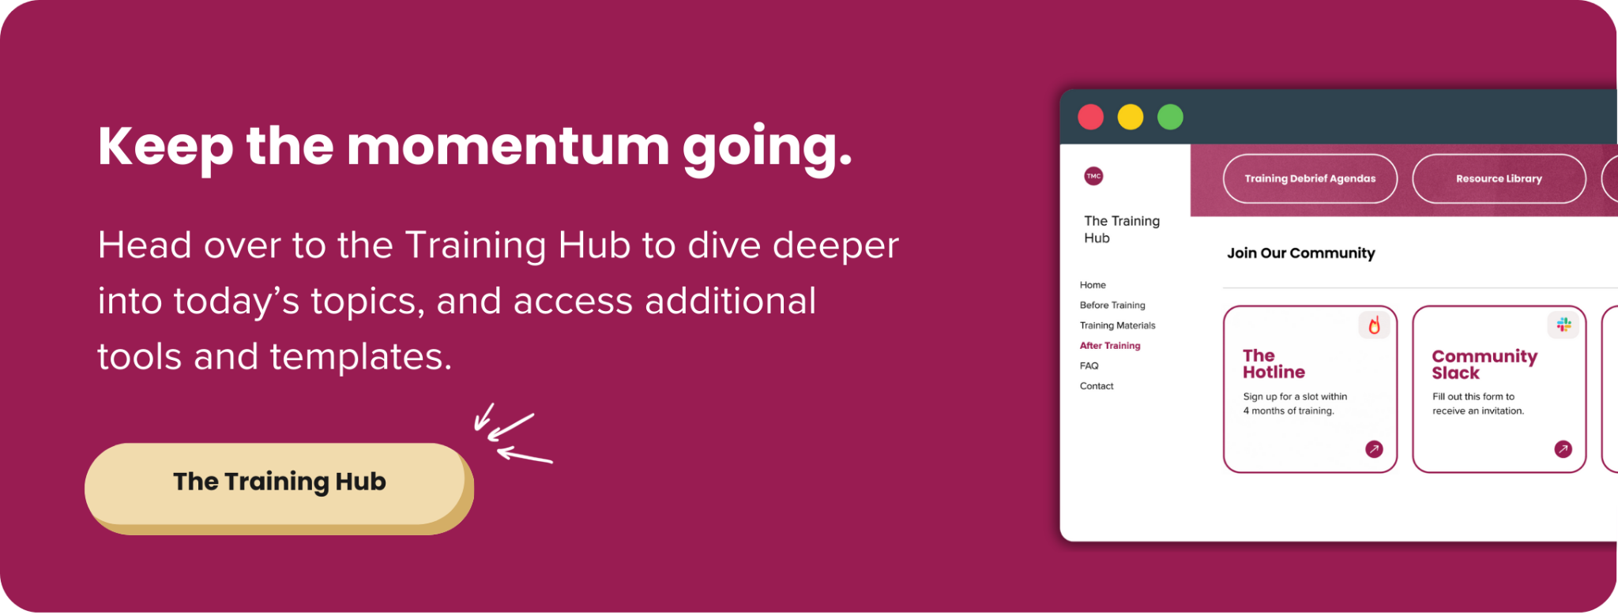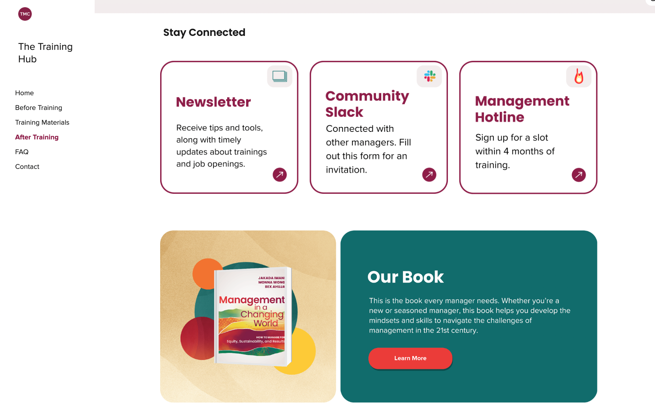

Tools and concepts we covered today
✅ | Spotting Performance Problems
✅ | Choice Points
✅ | 4 Steps to Addressing Performance Problems
✅ | I Do, We Do, You Do and Stretch Assignments
✅ | Feedback and Debriefs
✅ | Retaining Staff

