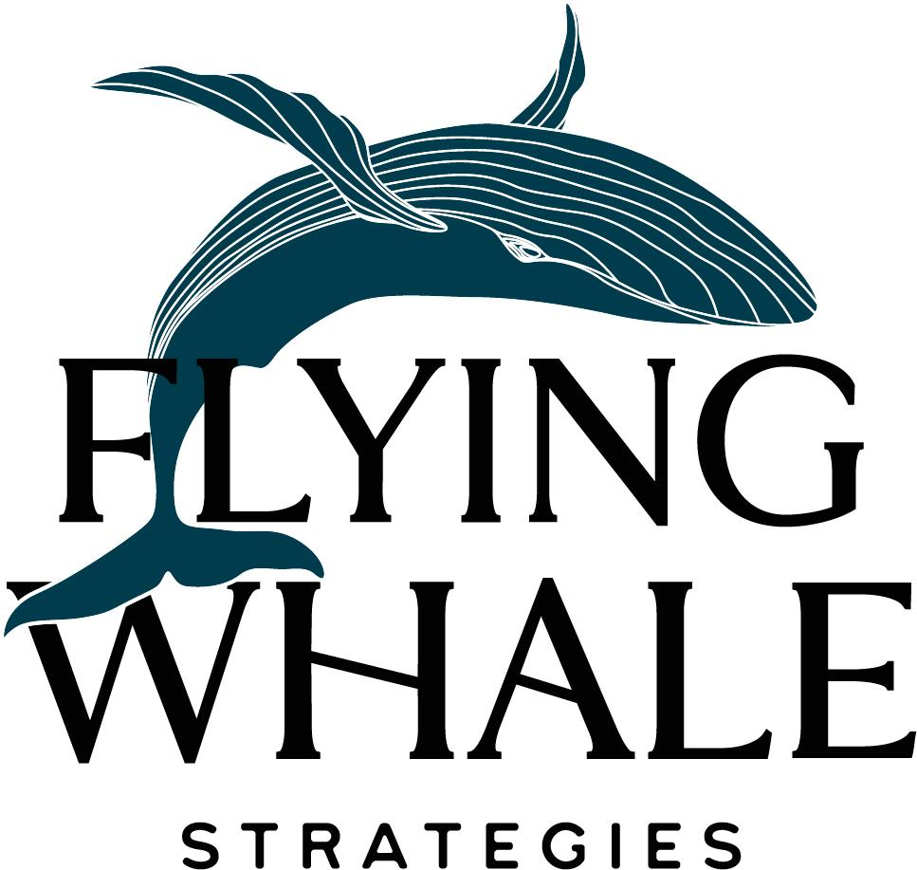

Grant/Proposal Writing Toolkit

Winning Proposal Self-Review Checklist

Clarity
- Is it clear what we do?
Is our description of the organization clear enough to be memorable?
Can someone repeat what we do at the dinner table?
Example:
Justice Defenders trains paralegals and lawyers within defenseless communities to provide legal services for themselves and others.

- Is it clear what we will do with the money? Have we said, “With this grant, we will be able to…”
Examples:
Poor oral health places life-long limits on speaking, eating, confidence, life quality, and career growth. Funds will ensure dental care to Colorado’s at-risk youth via full service dental care and education. More specifically, in partnership with the (Name of) Foundation, (Organization) will direct funds to generate progress toward our organization’s missional goals:
- Improve perceptions of dental care, to improve behaviors, by embedding oral health as integral to a child’s overall well-being.
- Increase health equity for youth in underserved communities by providing dental care that utilizes innovative and collaborative models.
- Empower dental health advocacy in and by the communities we serve through education and activation of stakeholders.

Or.
(Organization) respectfully requests a $x grant, which will support (Organization) in three significant ways. First, it will equip us with the resources necessary to continue our successful model of long-term outdoor education and youth empowerment programming for approximately 130 Washington, DC youth annually. Second, it will help us expand our College Success and Alumni Services to meet the need for continuing guidance and hands-on help for our youth as they make their postsecondary transitions. Finally, support from the X Foundation will help (Organization) implement our newly defined Diversity, Equity, and Inclusion (DEI) Statement of Beliefs.

- Is the problem we are trying to solve explicitly stated?
- Is that problem simplified?
Example:
Our country’s education and employment structures are largely outdated, ineffective, and inequitable, especially for youth on the margins. This leaves us vulnerable and inefficient as we train the next generation for the new economy.

- Is the solution we offer to the problem explicitly stated?
- Is that solution simplified?
Example:
Young adults disconnected from school and/or work are invited into a year-long apprenticeship as humble learners of life, self, and craft, within a high standards enterprise. Through deep work and deep learning, apprentices build skills, mindsets, networks and economic capital for sustainable careers, and most importantly, discover their own inherent greatness.

Bold Impact
- Are we articulating a bold, definitive impact statement somewhere in the proposal? Especially in the outcomes or evaluation section?
Examples:
- Neighborhood Industries: Community ownership will replace community poverty within neighborhood economies in California.
- EMERGE Minnesota: We will double the earning power for all BIPOC entry level employees in the Twin Cities by 2040.
- Sister Hearts: A decarceration program to accompany every institution that incarcerates.
- CoBuild: Youth who lived in affordable housing will run the companies that build the homes the next generation can afford and be proud of.
- EMERGE Connecticut: We will remove the shame of incarceration within our lifetime.
- Better Futures: Better Futures Minnesota will end the negative impacts of unemployment and underemployment for justice involved individuals.

- Are we articulating outcomes rather than outputs? Outcomes: how people/places/things will be transformed as a result of our work.
Examples:
- By 2026, 95% of program participants will recreate themselves measured by indicators of personal identity development.
- By 2026, 68% of formerly incarcerated individuals completing our program will return to serve and mentor others.
- By 2026, we will provide decarceration programming in 10 additional prisons.
- By 2026, 85% of the individuals we employ will demonstrate economic mobility.
- By 2026, 85% of the individuals we serve will increase earning power.
- By 2026, 85% of the individuals we serve will exit cycles of poverty.

Experience
- Are we conveying that we are the organization capable of achieving this impact due to our experience?
- Is our track record clear?
Examples:
- Our founder, Maryam Henderson Uloho is asked to speak on the topic of decarceration and the SisterHearts program to a national audience on a monthly basis.
- (Organization’s) trust-based approach is evidence-based. (Organization) has over 110 years of experience working with Colorado’s kids in need. This history has grounded us in the real challenges families face.
- (Organization) has been asked to inform the work of national partners serving opportunity youth by speaking to attendees at the Sample Forum alongside panelist from x Organization, x Organization, and x Organization. In 2018, our Executive Director was a Plenary Session panelist alongside x Organization. Finally, Sample Nonprofit was a site visit location for the x Organization on K-12 Philanthropy and asked to speak to participants on Sample Nonprofit’s unique model. In addition, Sample Nonprofit is contributing writer on Forbes.com’s Grads of Life blog, and a chapter author on the forthcoming x publication by the Institute for Workplace Skills and Innovation America. Sample Nonprofit has been an annual guest presenter at the x Gathering in Los Angeles since August 2016.

Supplemental Learning

Yield Giving Scoring Rubric
If you wish to see how the MacKenzie Scott funding was peer-reviewed, including a specific section on the team’s experience.

Grant Response Quality Improvement Example
If you wish to see three levels of improvement to a grant question that asks about impact.

Y Combinator Presentation on Pitch Decks
If you wish to see how the Y Combinator trains entrepreneurs in developing winning pitch decks.

Major Gift Proposal Template

