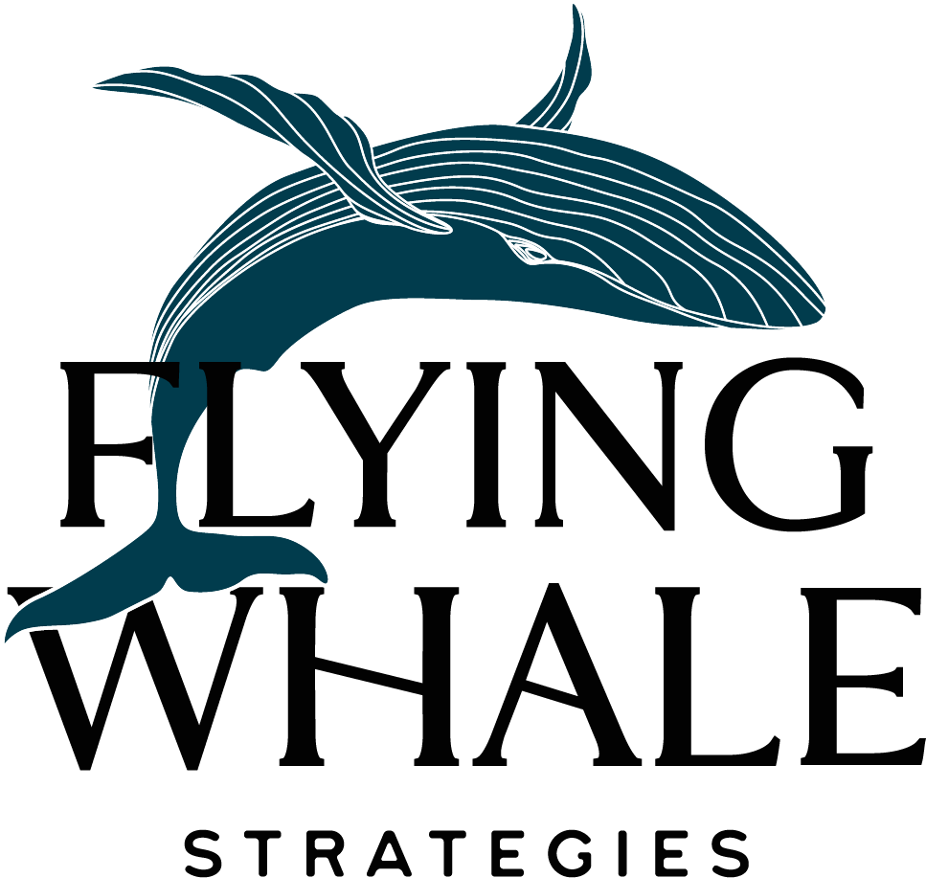

Fundraising Strategy:
Scoring Rubric

As you learn about each fundraising strategy, rank them across the columns on a scale of 1-5.
1=not at all
5=extremely

 | How sustainable is it for us? | How strong is the return on investment for us? | How quickly will the money come in? | How interested are these donors in our mission? | How well does it work in our fundraising landscape? | How simple is it to operate? | TOTAL SCORE (total possible=30)
Major Gifts
Annual Giving
Events
Grants
Corporate Sponsorships

Please use the following to audit your organization’s fundraising strategies. As you learn the implications of each strategy, consider the effectiveness of your own.

Please rate your response to each factor listed below using the following scale:
1: Not at all true
2: Mostly not true
3: Somewhat true
4: Mostly true
5: Completely true

MAJOR GIFTS
Factor | Score
There is evidence of current donors with untapped major gift capacity and propensity | 3
We have significant connectors | 3
Our specific program goals inspire transformational gifts and we can clearly demonstrate impact | 3
The problem we are designed to solve is an appealing investment for individual donors | 4
We are willing to allow restricted gifts | 4
We are prepared for a 6-8 month investment cycle | 5
We have or are willing to set up a system to manage donor portfolio (Full time officer holds +/- 100 donors on portfolio at a time) and spend at least 10 hours/week on the daily practice | 4
We have or are willing to invest in staffing to support the program such as a Major Gift Officer and a Portfolio Specialist as well as collateral and a travel budget | 3
This strategy is well matched with the trajectory of our revenue goals | 4
The Return on Investment for this strategy seems high for us | 4
This strategy is aligned with the current lifecycle of our organization | 4
TOTAL | 41

ANNUAL GIVING
Factor | Score
We have a high tolerance for a long runway (you will not receive a return on investment for 18 months) and can make an upfront investment | 3
The problem we are designed to solve is appealing or can be made appealing to a mass scalable audience | 5
We’re prepared to apply direct response science to the fundraising operation | 3
We have a competency and proclivity to storytelling through words and imagery | 4
We have or are willing to source the ability to write, manage a communications calendar, analyze and report on tactical performance, etc. | 3
We have or are willing to acquire a robust CRM system to support gift acknowledgement and receipting | 4
We have or are willing to build strong communication and online giving platforms | 4
We have or are willing to invest in staffing to support this strategy, such as: annual giving manager, database/reporting manager, donor relations specialist, communications specialist | 3
This strategy is well matched with the trajectory of our revenue goals | 3
The Return on Investment for this strategy seems high for us | 3
This strategy is aligned with the current lifecycle of our organization | 4
TOTAL | 39

EVENTS
Factor | Score
Our programming benefits from telling a story in a specific time and place | 3
You have the proclivity for designing and producing transformational experiences | 3
The problem we are designed to solve is appealing or can be made appealing to communities of individuals | 4
The life stage of the organization matches the lift necessary to host a successful event (Cost to raise $1 is less than $.35 by year 3) | 2
We have the reach to efficiently exceed participation goals | 2
We have or can acquire a CRM, gift acknowledgement, and receipting process | 4
We have or can build strong communications platforms | 3
We have or can support staffing for this strategy: Events Manager, Events Specialist (logistics), and a Communications Specialist | 2
This strategy is well matched with the trajectory of our revenue goals | 3
The Return on Investment for this strategy seems high for us | 2
This strategy is aligned with the current lifecycle of our organization | 4
TOTAL | 32

GRANTS
Factor | Score
We have a strong outcome-driven logic model fueled by clear program design | 2
We have a program model that appeals to multiple funding priorities (ie: workforce development funding and mental health funding might apply to your program) | 5
The problem we are designed to solve is appealing or can be made appealing to institutions and can compete with other organizations similar to us | 3
We have strong evaluation and reporting infrastructure | 2
We have or can acquire a grant portfolio management process | 3
We have or can create a grant language sourcebook | 3
We have or can create a process for field-generated reporting | 3
We have or can support staffing for this strategy: relationship manager, grant writer/report writer | 3
This strategy is well matched with the trajectory of our revenue goals | 3
The Return on Investment for this strategy seems high for us | 3
This strategy is aligned with the current lifecycle of our organization | 4
TOTAL | 34

CORPORATE SPONSORSHIPS
Factor | Score
Our organization is positioned to expand the public reach of corporate brands | 5
Our programming naturally produces opportunities for mass volunteerism or employee engagement | 4
The problem we are designed to solve is appealing or can be made appealing to corporate entities | 4
We’re willing to invest in the development of sponsorable assets | 4
We understand and accept the liabilities of corporate alignment | 3
We have or are willing to invest in marketing and collateral assets | 3
We have or are willing to acquire a system to manage a sponsorship portfolio | 3
We have or are willing to support staffing for this strategy: staff to fulfill sponsorship benefits (Fulfillment Specialist), manage volunteers (Volunteer Coordinator), and develop sponsorships (Sponsorship Officer) | 4
This strategy is well matched with the trajectory of our revenue goals | 4
The Return on Investment for this strategy seems high for us | 4
This strategy is aligned with the current lifecycle of our organization | 3
TOTAL | 41

TOTALS
Major Gifts | 41
Annual Giving | 39
Events | 32
Grants | 34
Corporate Sponsorships | 41

Note: The scores on this rubric are designed only to supplement your decision-making process. They should not be interpreted as the only data point.

