  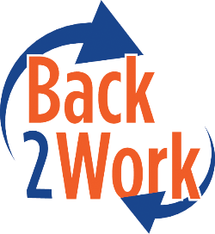  Description  Northern & Central Regional Meeting Minutes  Wednesday, June 10, 2026 | Presenter
Welcome & Introductions | Jessica
Department Updates:  • Contract Updates  - Future funding has been approved to extend the current 1-Year TEMP contracts through August 2027.  - BCOE is currently working on the TMP amendment and anticipates sharing it soon.  - Separately, BCOE is working with Headquarters to pursue an increase to the daily rate  • Inclement Weather MEMO  - Review Heat Illness Prevention procedures and follow all applicable protocols during periods of extreme heat.  - Caltrans determines whether crews are canceled due to inclement weather when work cannot be performed safely. If there are safety concerns, please notify BCOE.  • Non-Operating Days in June  - Please be aware of the upcoming dates of June 18–19 and July 3–5.  • Feedback  - Updated Incident Report  - Feedback was received that the “Submit” function does not always clearly indicate when an item has been submitted to BCOE.  - Updated Invoicing  - Invoice Training is available on the B2W Google Calendar. Sessions are Fridays, 9:00–10:30 a.m. Register by Thursday evening, or the session may be canceled due to low enrollment. | Jessica
Program & Training Specialist Updates  - Before and After Photo Submissions | Abraham
Community of Practice with Redefine Alliance  - New Work Requirements for SNAP in California | Redefine Alliance
Closing, End of Meeting | Jessica

